**BDAT 1009 Enterprise Analytics**

**Final Assignment**

**1) Churn Analytics (8%)**

* + Tenure

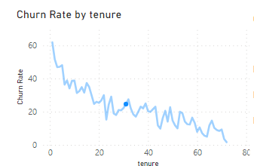

* + Product (Internet service – DSL vs Fiber Optic vs Other)

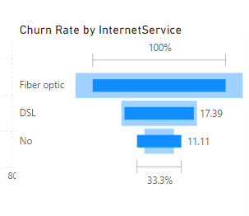

* + Contract

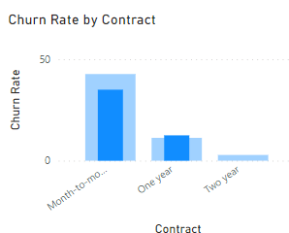

* + Monthly Charges ( Use range. E.g. High is Monthly charges > 100 etc.)

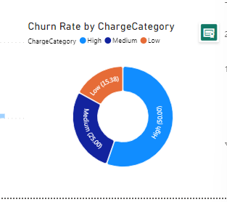

**IMPACT OF TENURE ON CHURN**

Customers with more tenure have less chance to leave.

Less tenure greater the chance of churn

**IMPACT OF CONTRACT ON CHURN**

Lower churn is observed for longer contract.

Higher churn is observed for month-to-month contract (smaller contract)

**IMPACT OF MONTHLY CHARGES**

Churn increases with higher charges is observed. Price is a big factor for churn.

**IMPACT OF INTERNET SERVICE**

Optic service has most churn observed than DSL.

**SMART Objective**

Try to reduce the churn rate by 5% in the next month and try to keep the customers with the tenure of less than 6 months.

It is smart because it is can outlines the customers with less tenure. And we are trying to achieve a specific target

It is measure able as well as it clearly shows try to reduce the churn by 5 %

It is realistic as well as we can achieve in a limited timeline of next month

It is aligns with the overall goal of reducing churn

It has a deadline as well as by the end of next month

**2) Balance Scorecard and Visualization (4%) -**

**FINANCIAL PERSPECTIVE**

Increase the profit by decreasing churn

Increase the profit

Decrease churn by 5%

Do important measure to do so

**CUSTOMER PERSPECTIVE**

We have to increase customer satisfaction

Keep an eye on NPS

Increase the customer by 4 in next month

We need to provide effective measures to win the satisfaction of customers

**INTERNAL PROCESSES PERSPECTIVE**

Make sure customer not to churn

We need to resolve customers complaints

Efficiently run customer service

LEARNING AND GROWTH PERSPCECTIVE

Develop skills to analyze churn

Give the employee training for it

Spare some time for it

Conduct regular programs for churn analysis

**KPI**

1. Churn rate
2. Customer retention rate try to keep an eye on customers loyalty
3. Churn impact on monthly revenue keep an eye on churn rate and revenue
4. Customer support resolution time Time to resolve customer issues
5. NPS Customer’s satisfaction

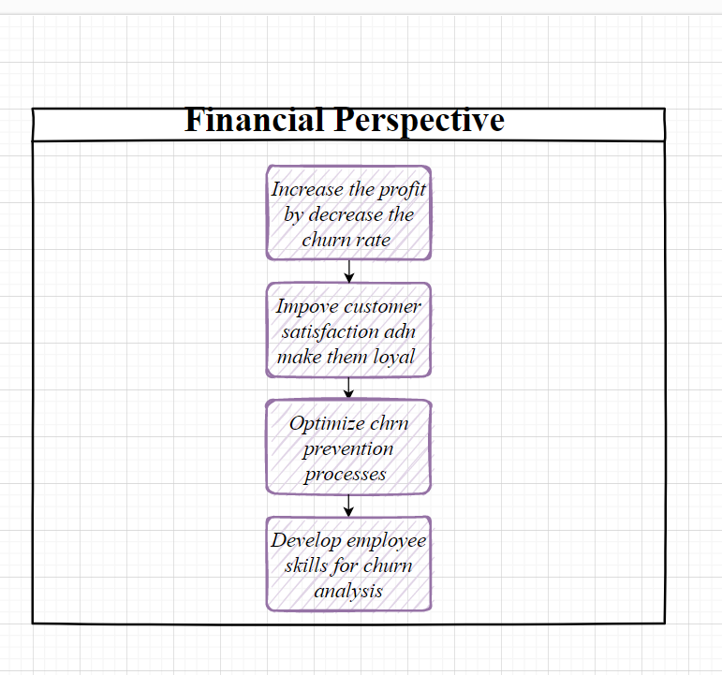

The dataset should contain all the information of about customers their interaction with company and the factors that can influence churn.

custId

age

gender

tenure

contract

monthly charges

total profit

churn impact

highest profit

NPS

Survey and feedback

Highest NPS  
customer support

Time to resolve issue.

Status

Churn preventive measure data

Employee training data

Skills development

Highest records

Churn rate

Customer retention rate

Monthly impact on profit due to churn

Lowest churn data

* **Dashboard**

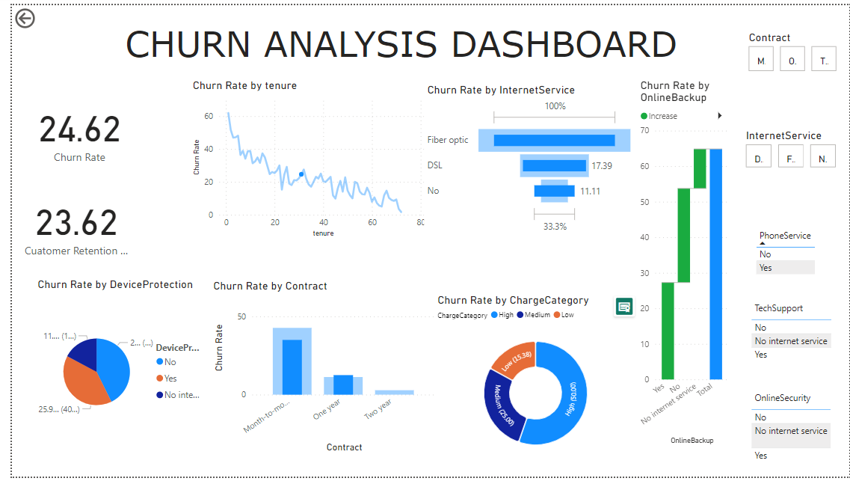

**https://app.powerbi.com/links/uI8ZtZKlEp?ctid=da9a94b6-4681-49bc-bd7c-bab9eac0ad3c&pbi_source=linkShare**

**3) Churn Prediction (4%)**

**I did use 3 techniques in RapidMiner.**

**Logistic Regression**

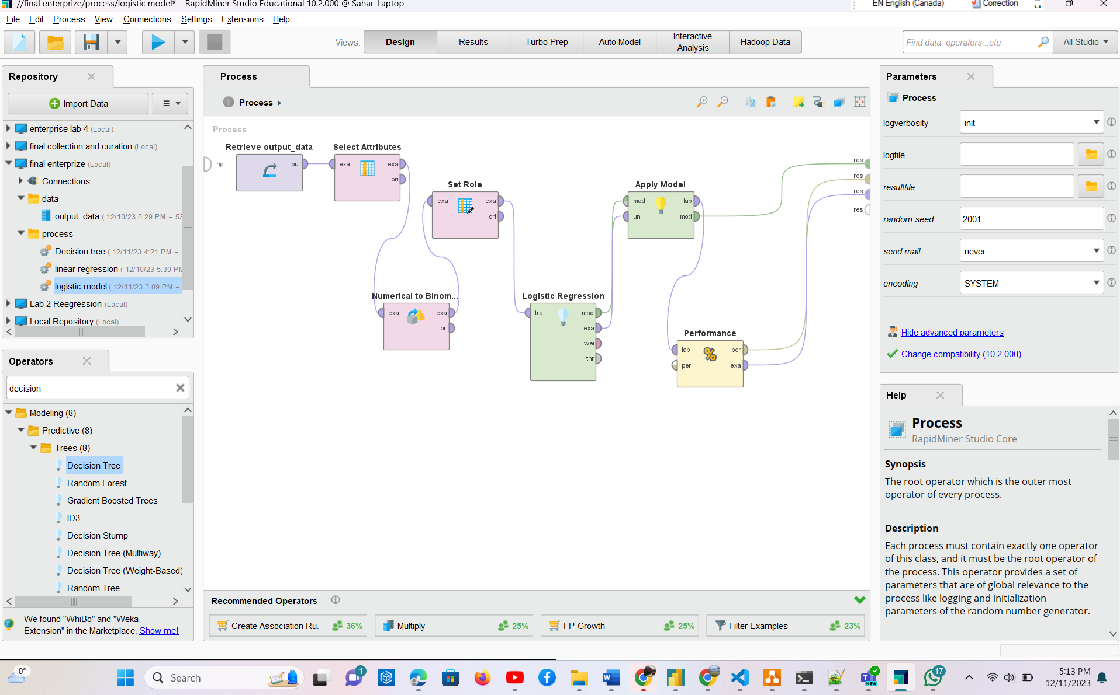

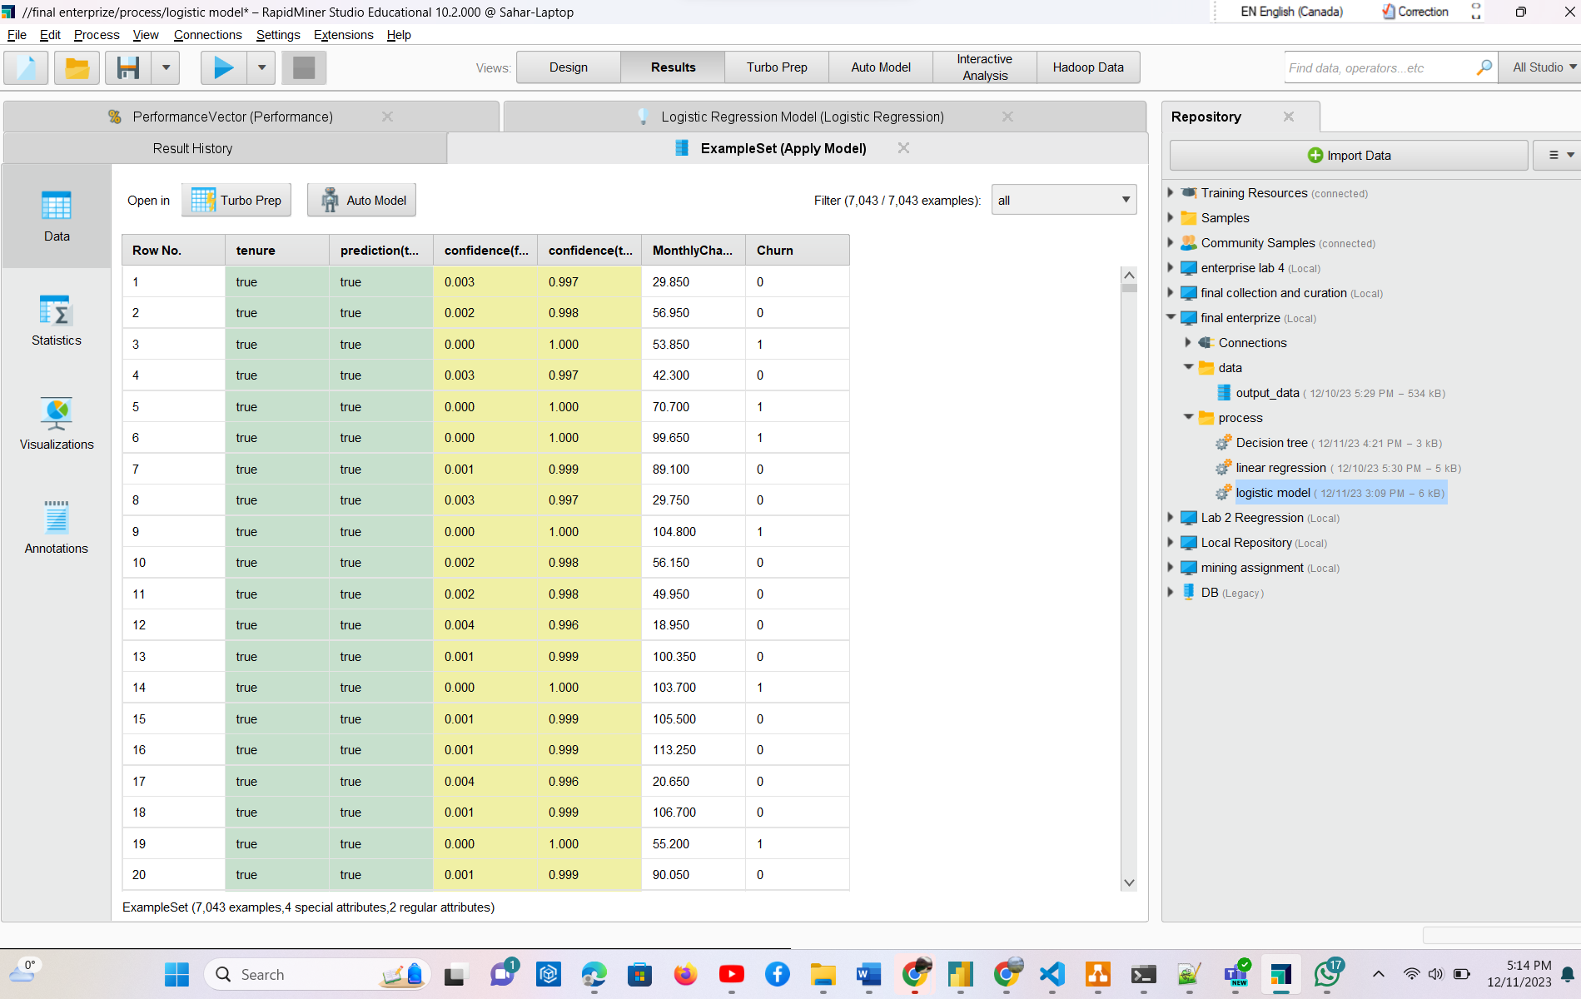

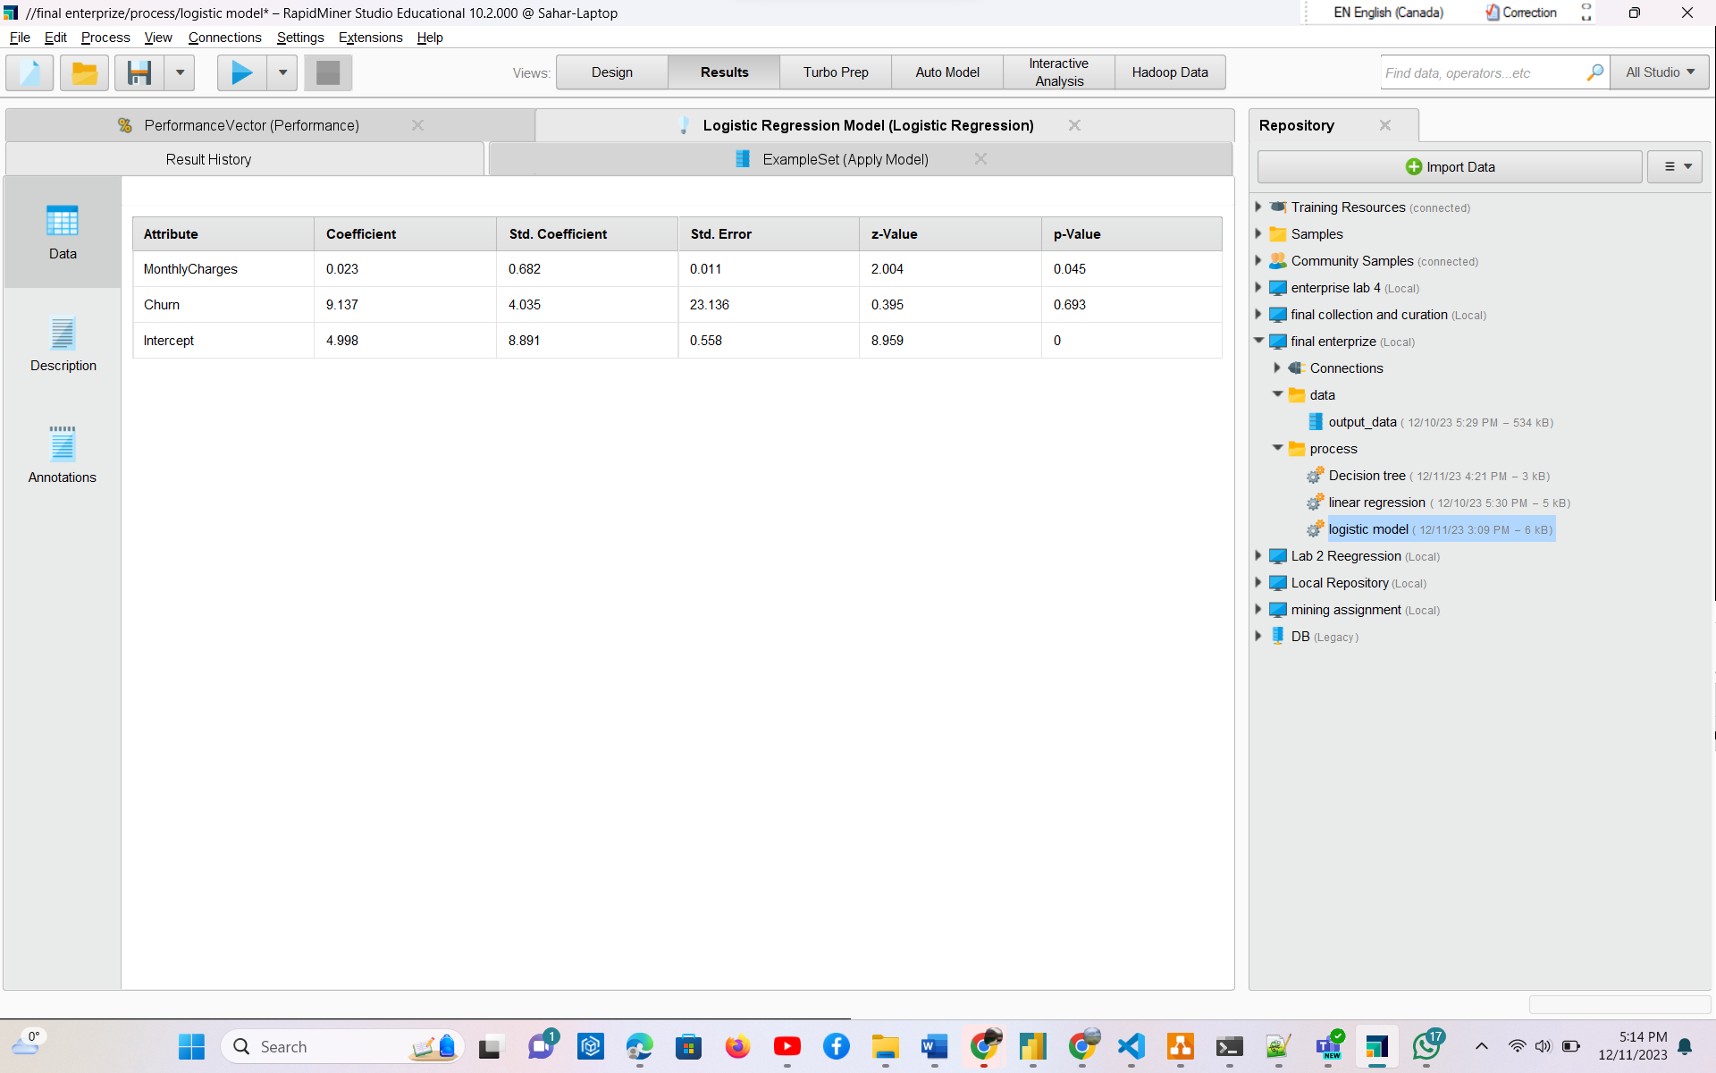

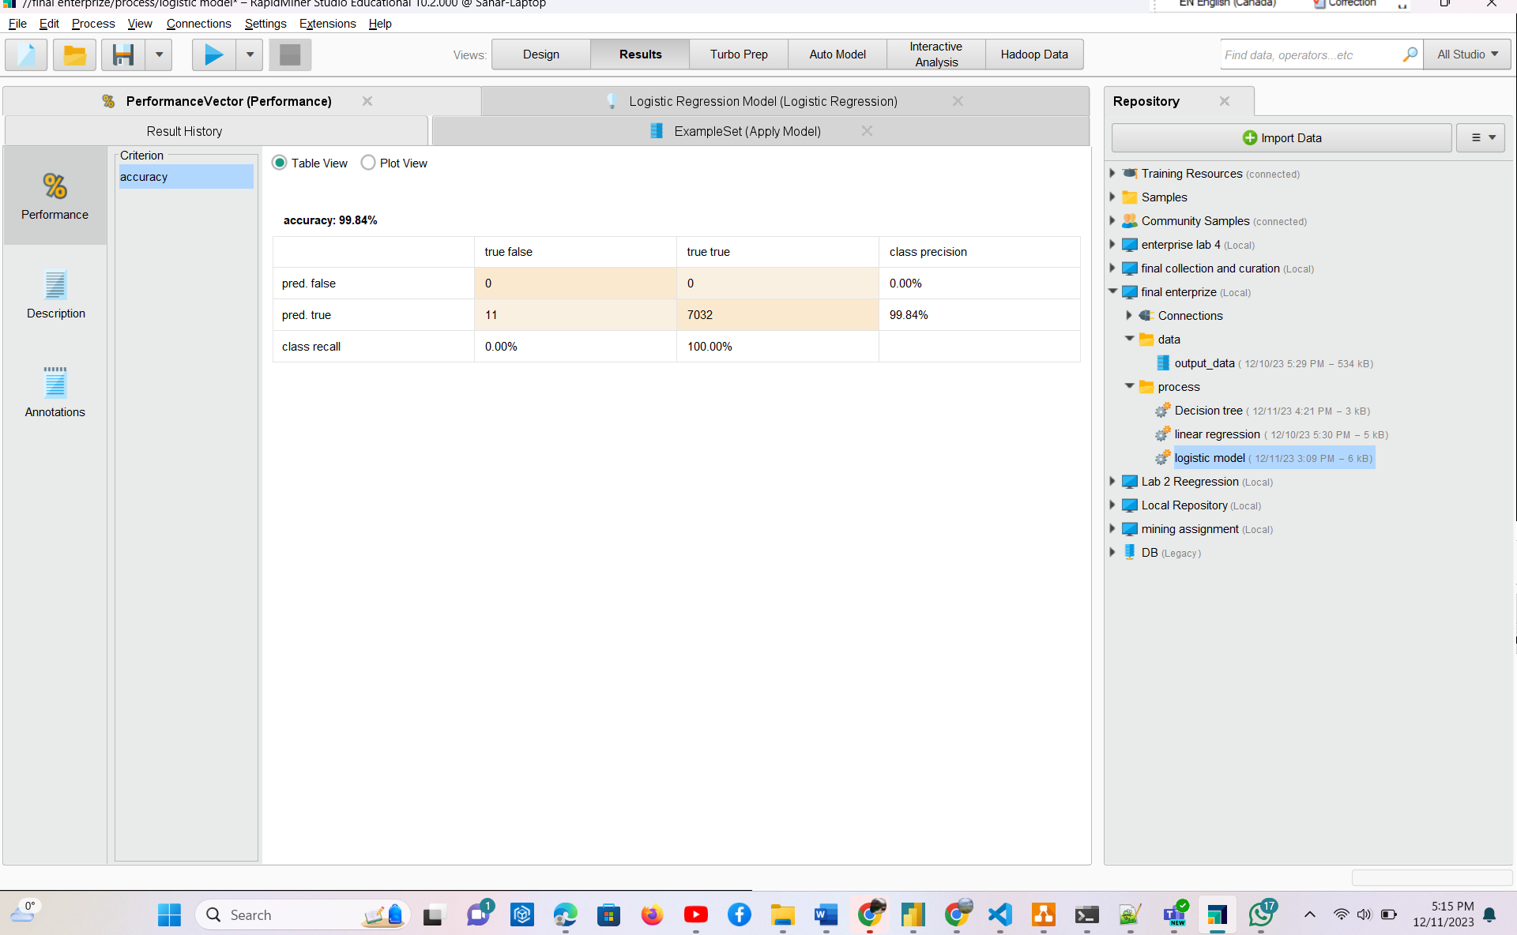

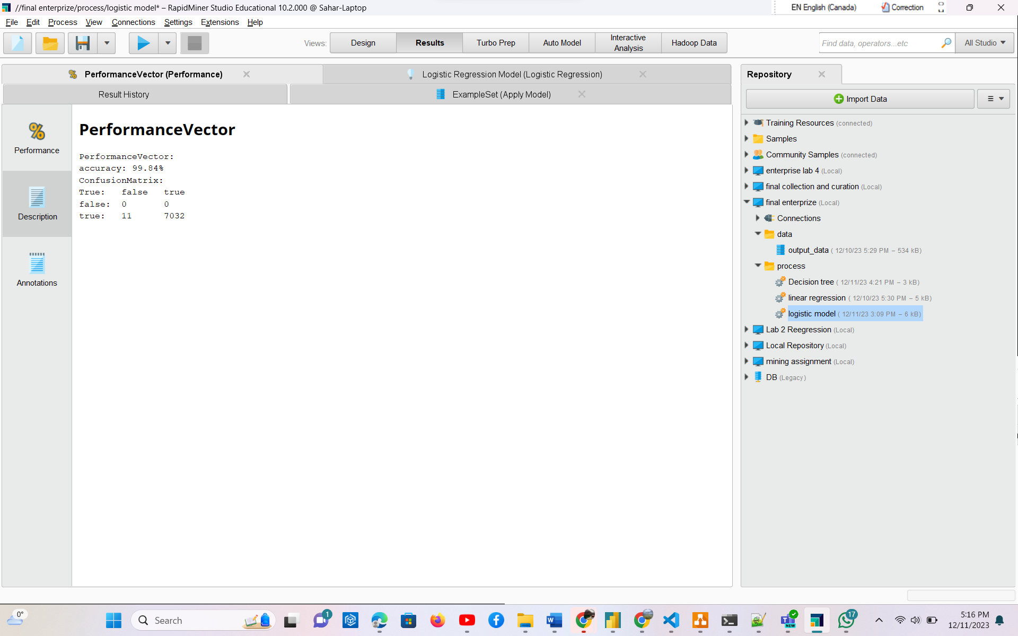

**Linear regression**

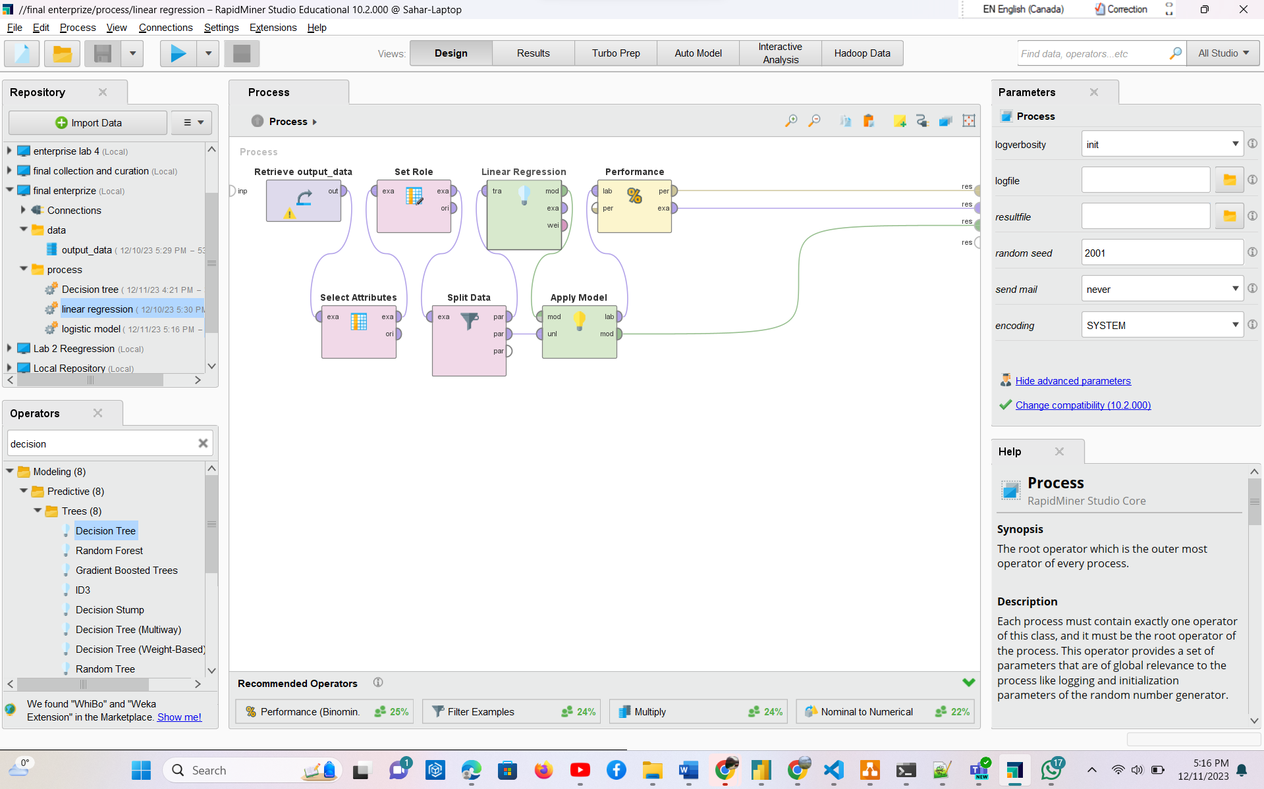

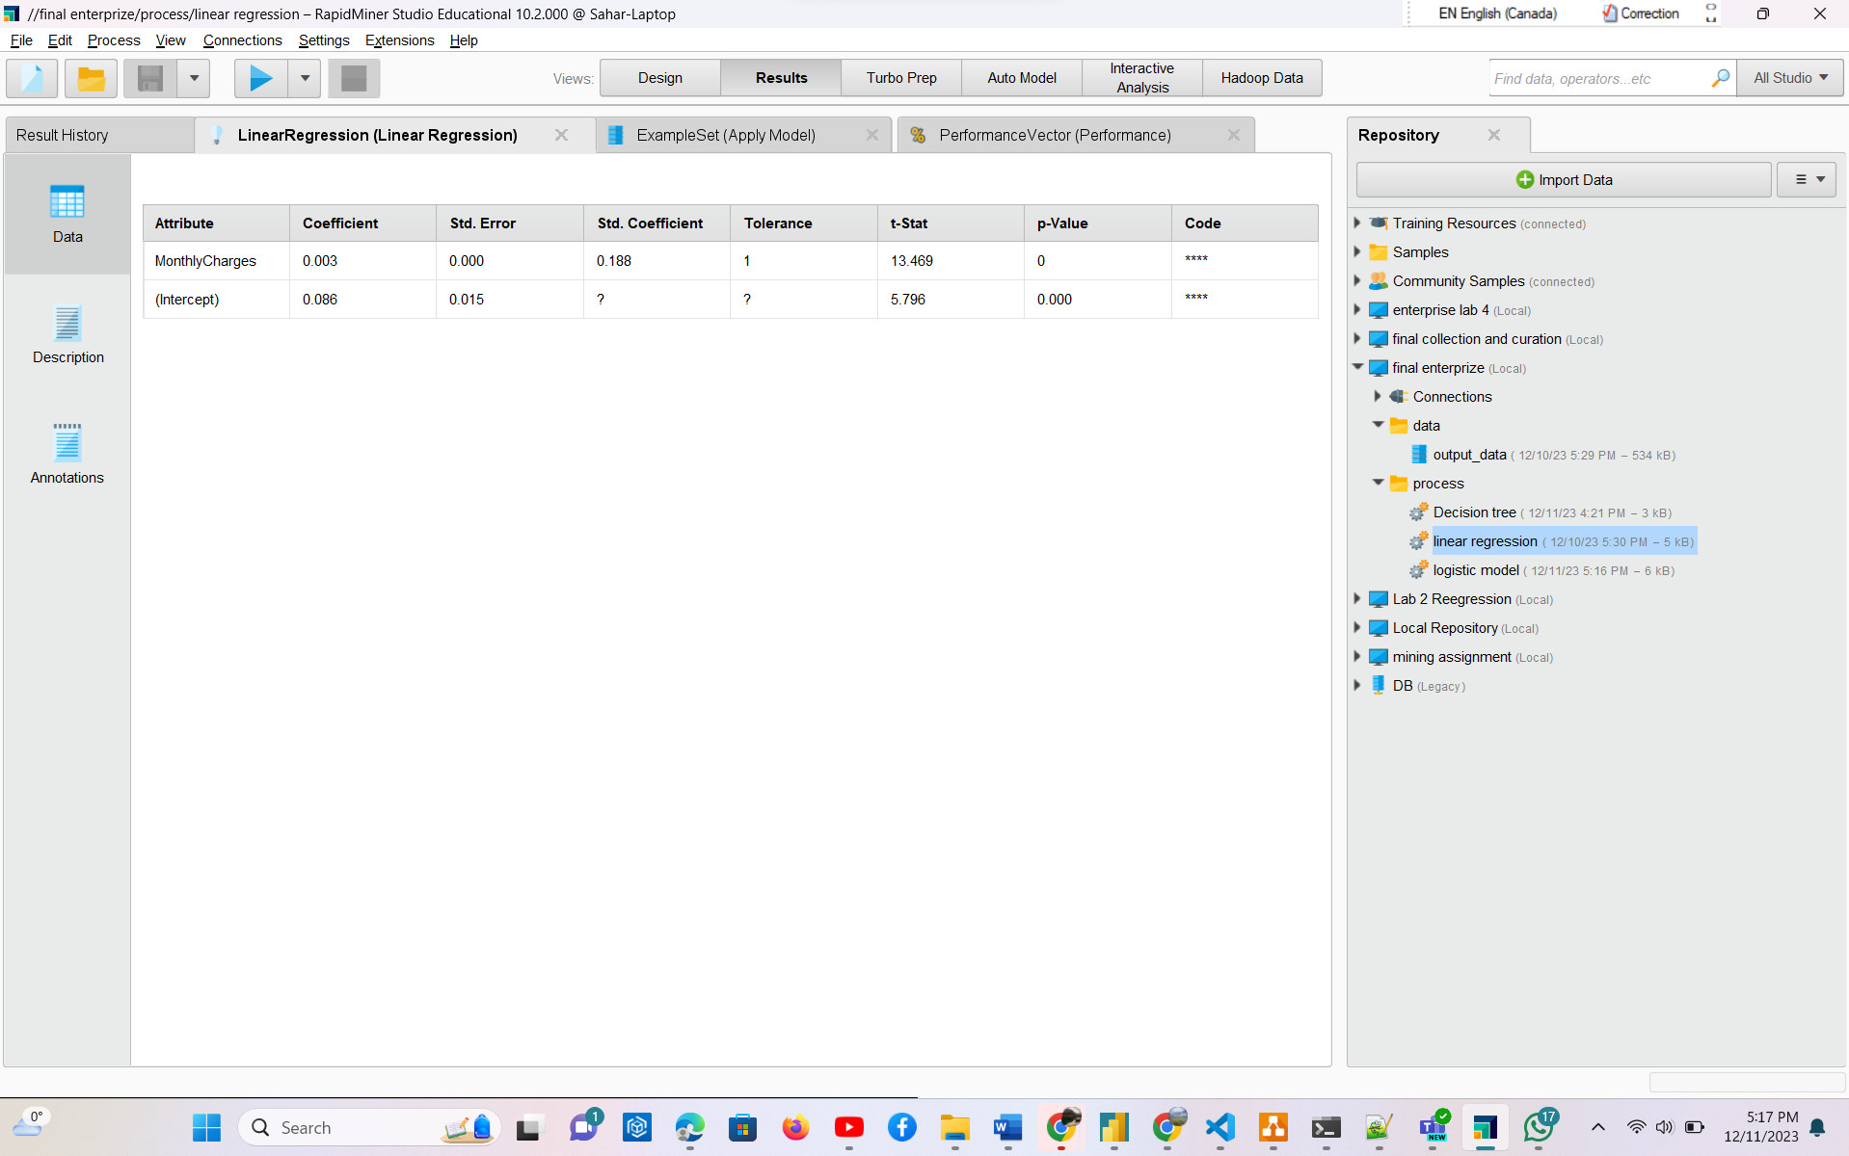

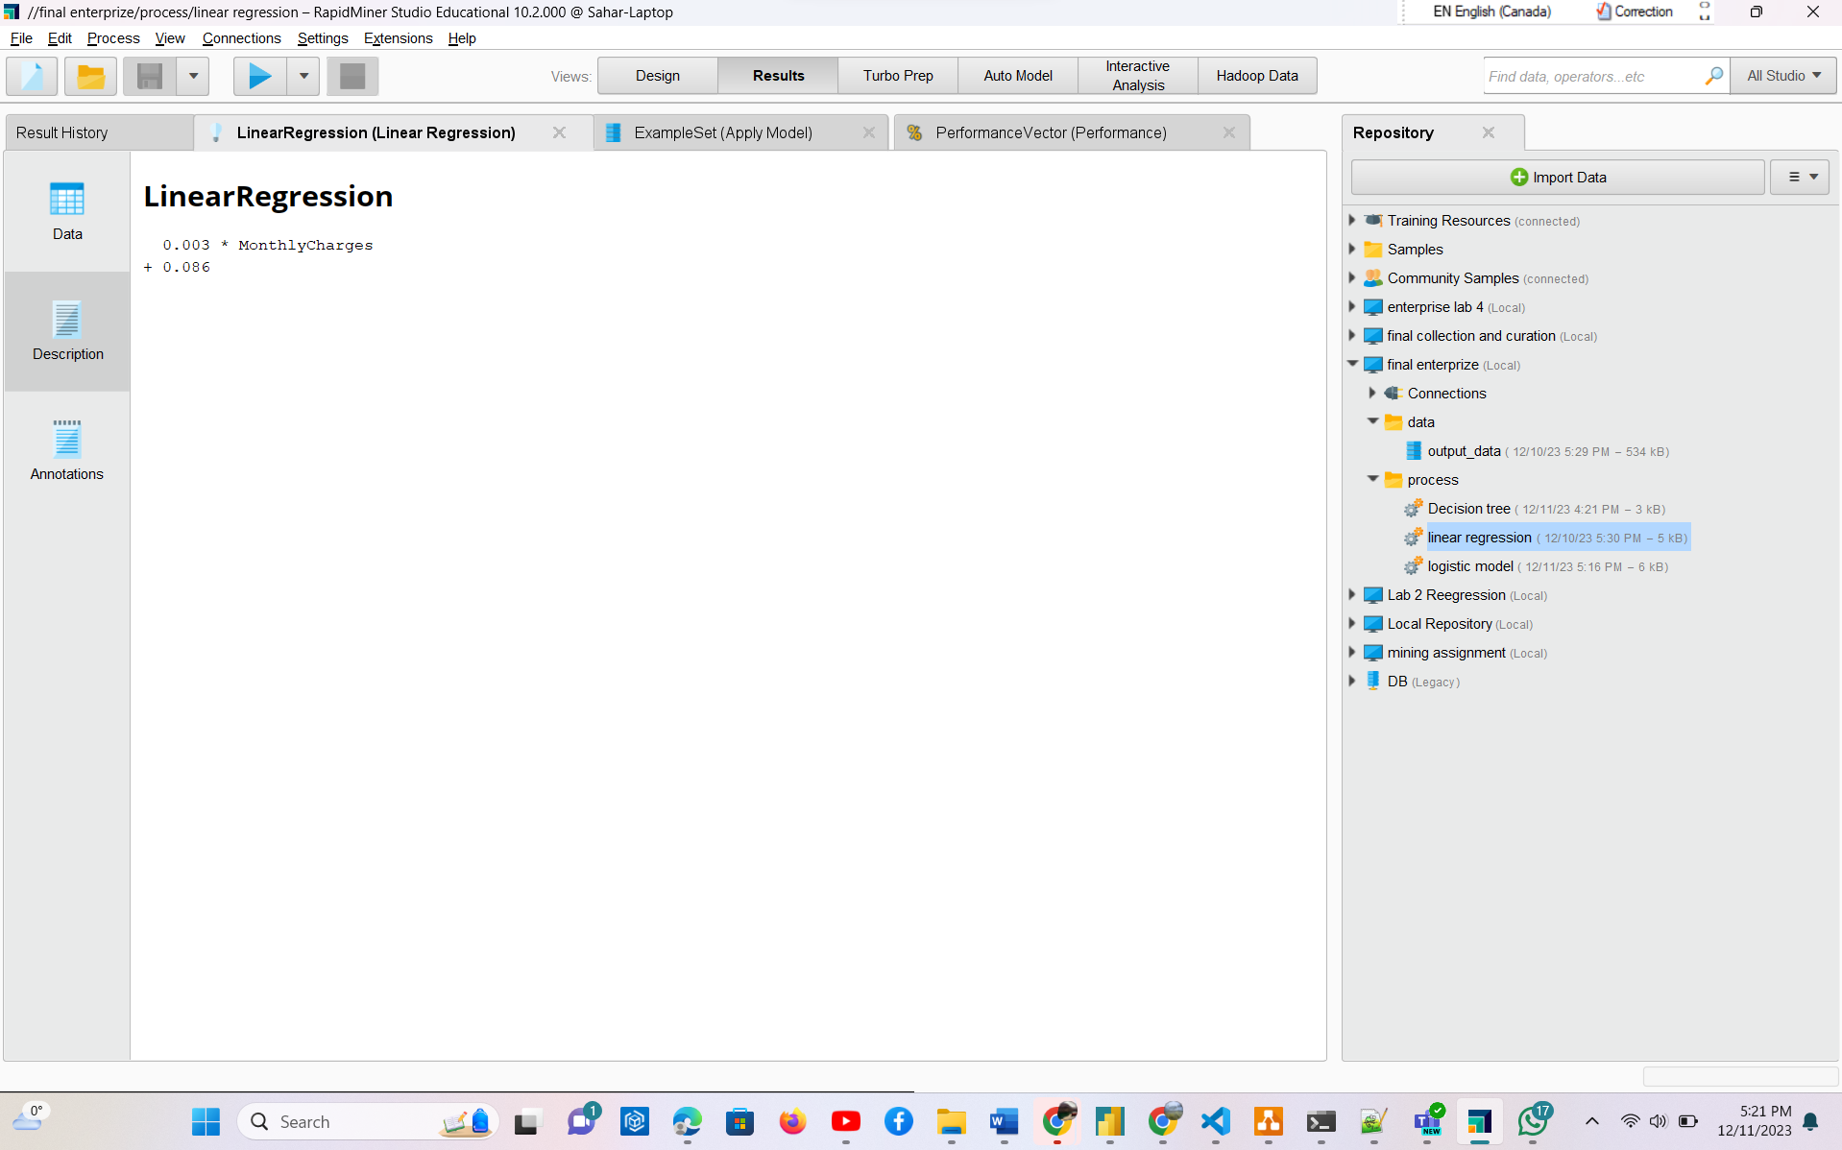

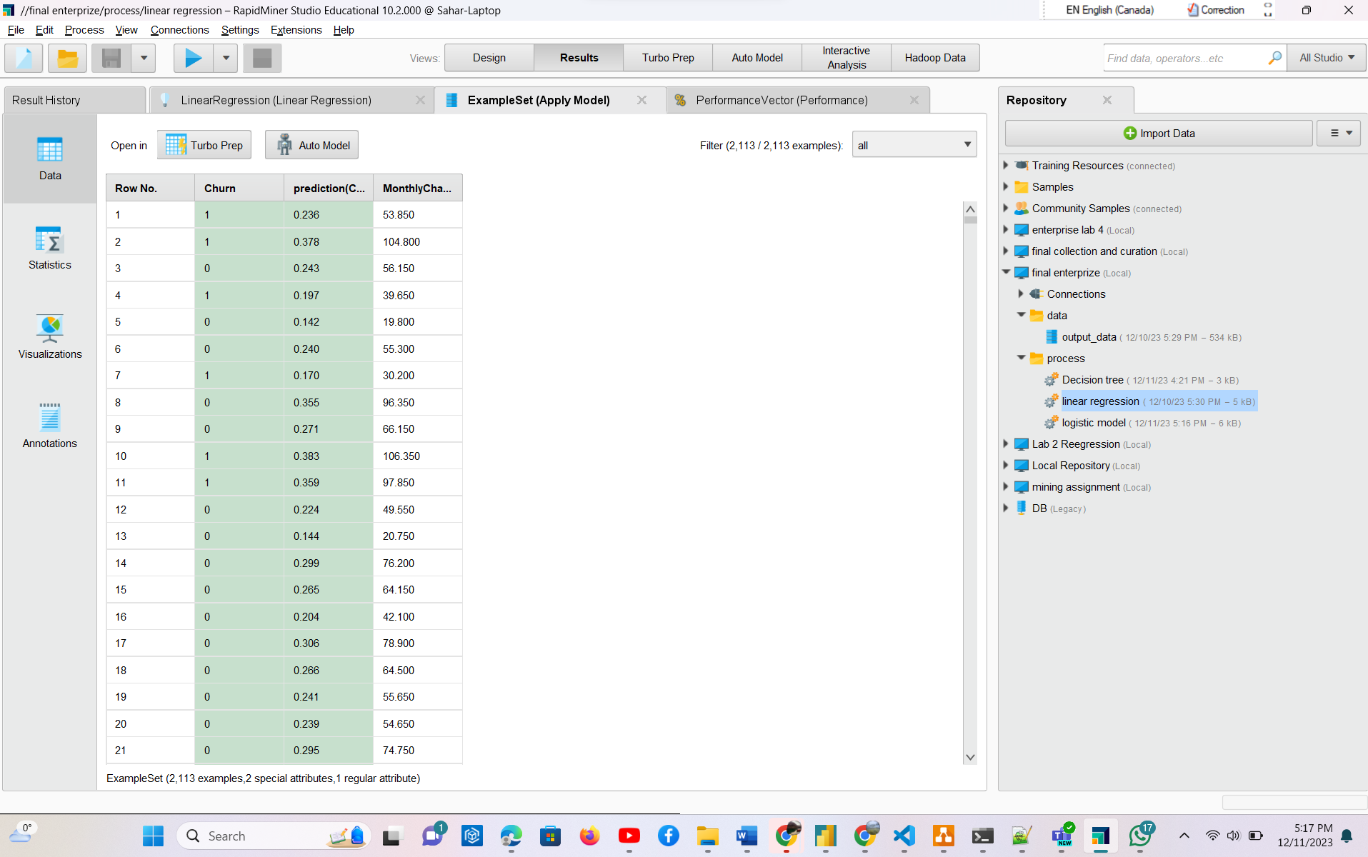

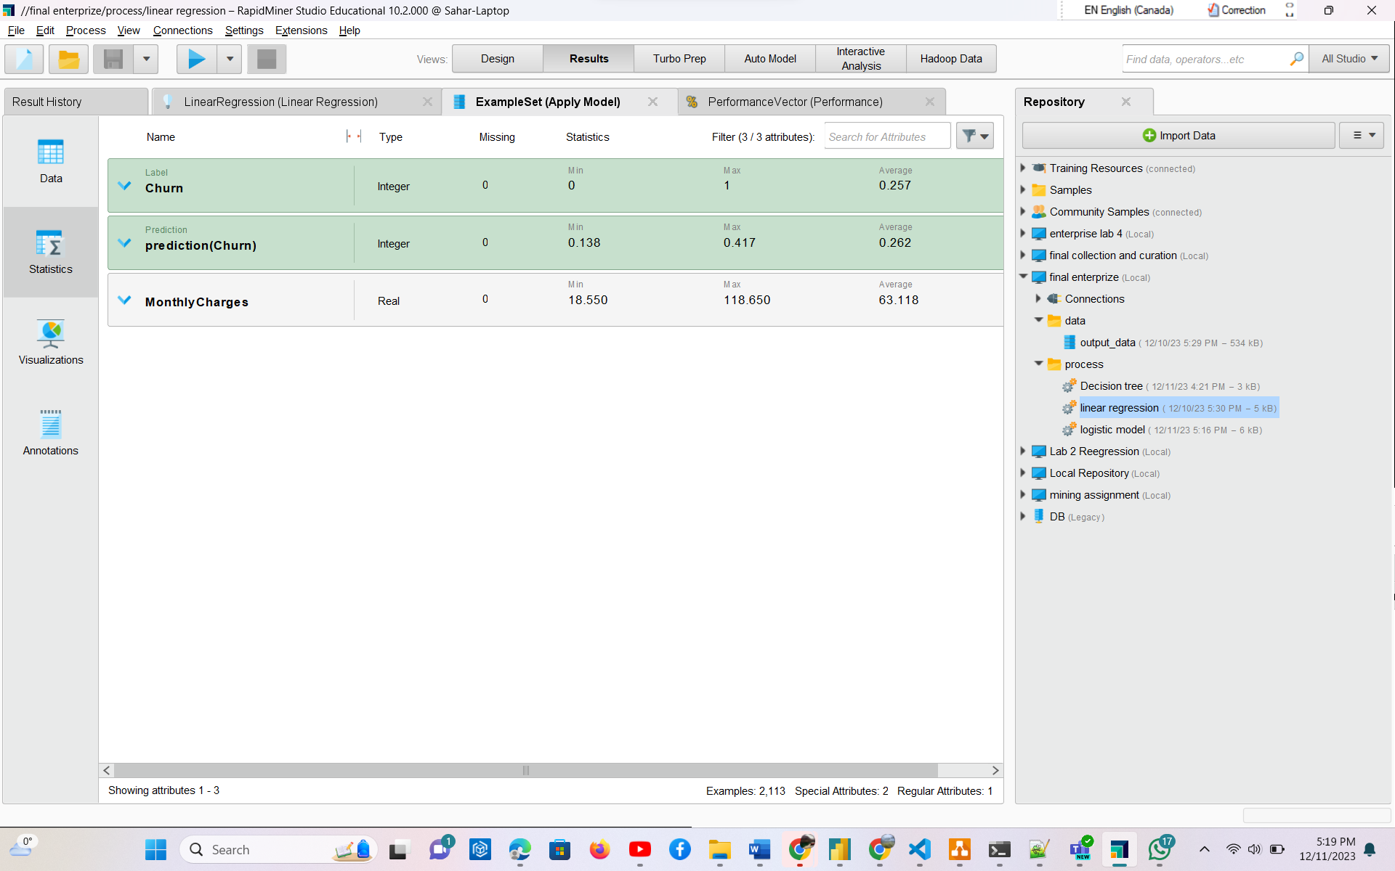

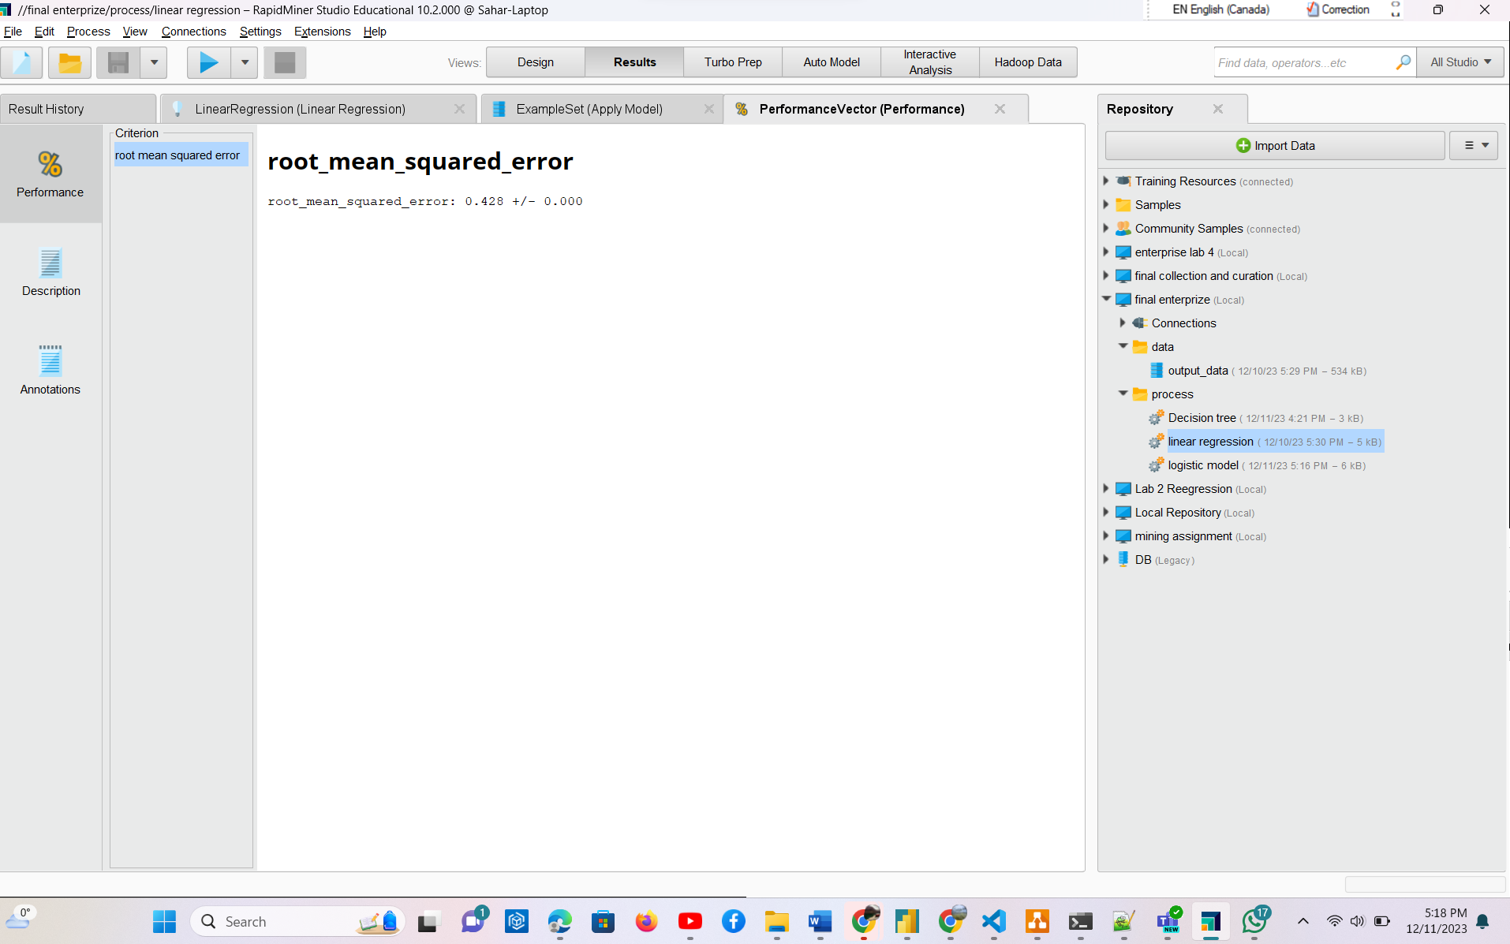

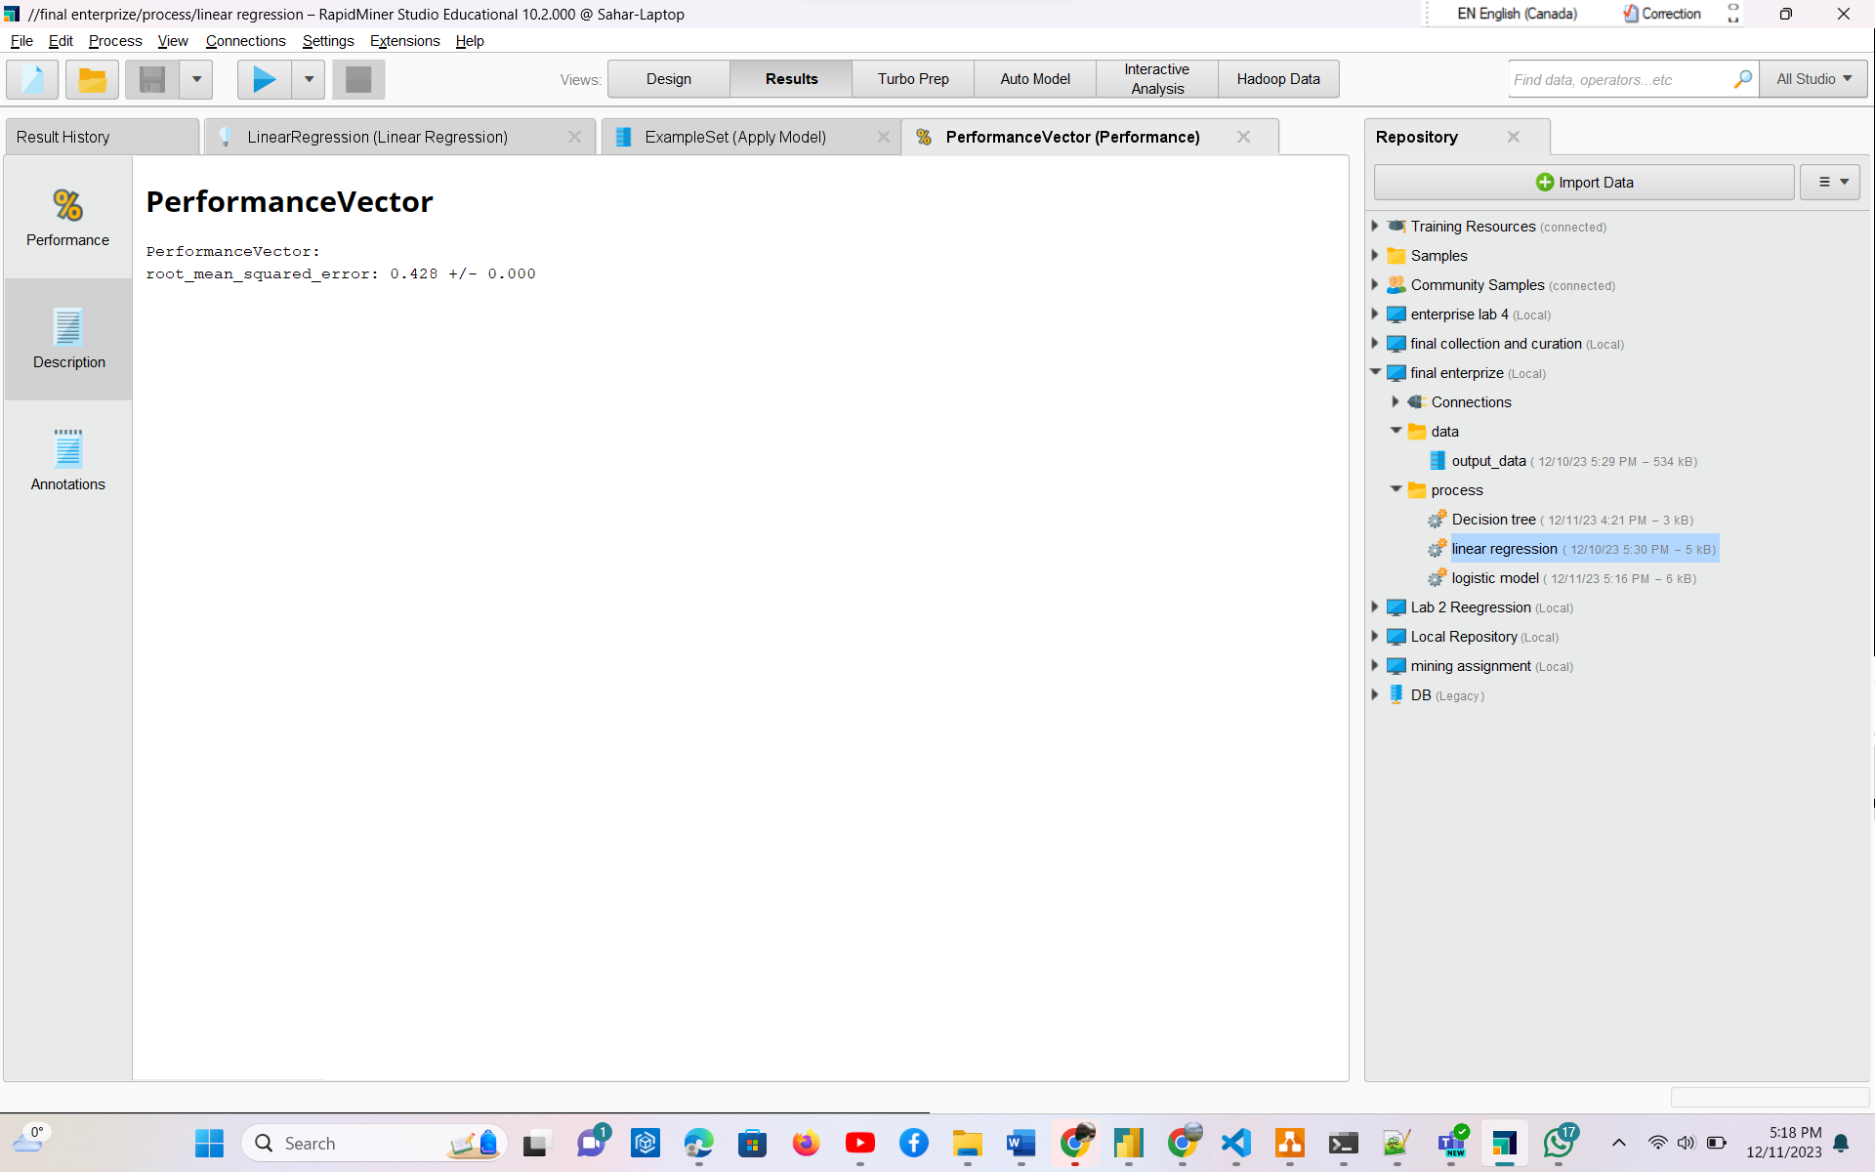

**Decision tree**

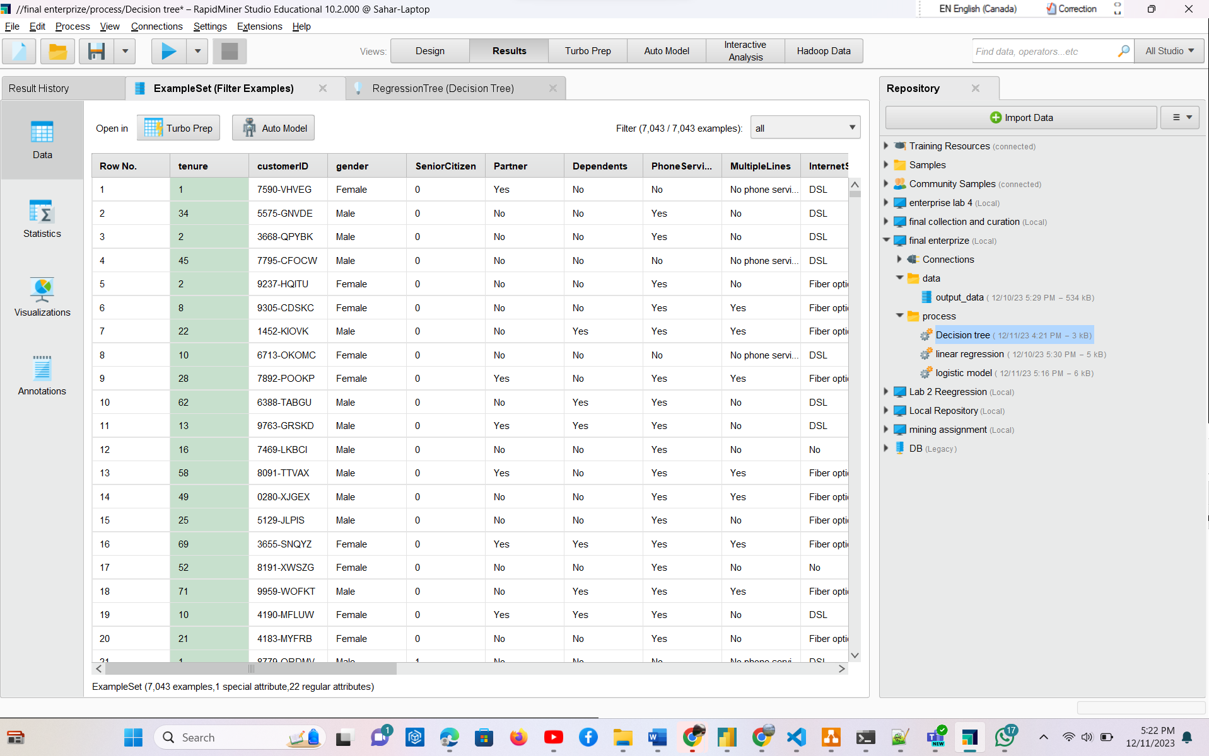

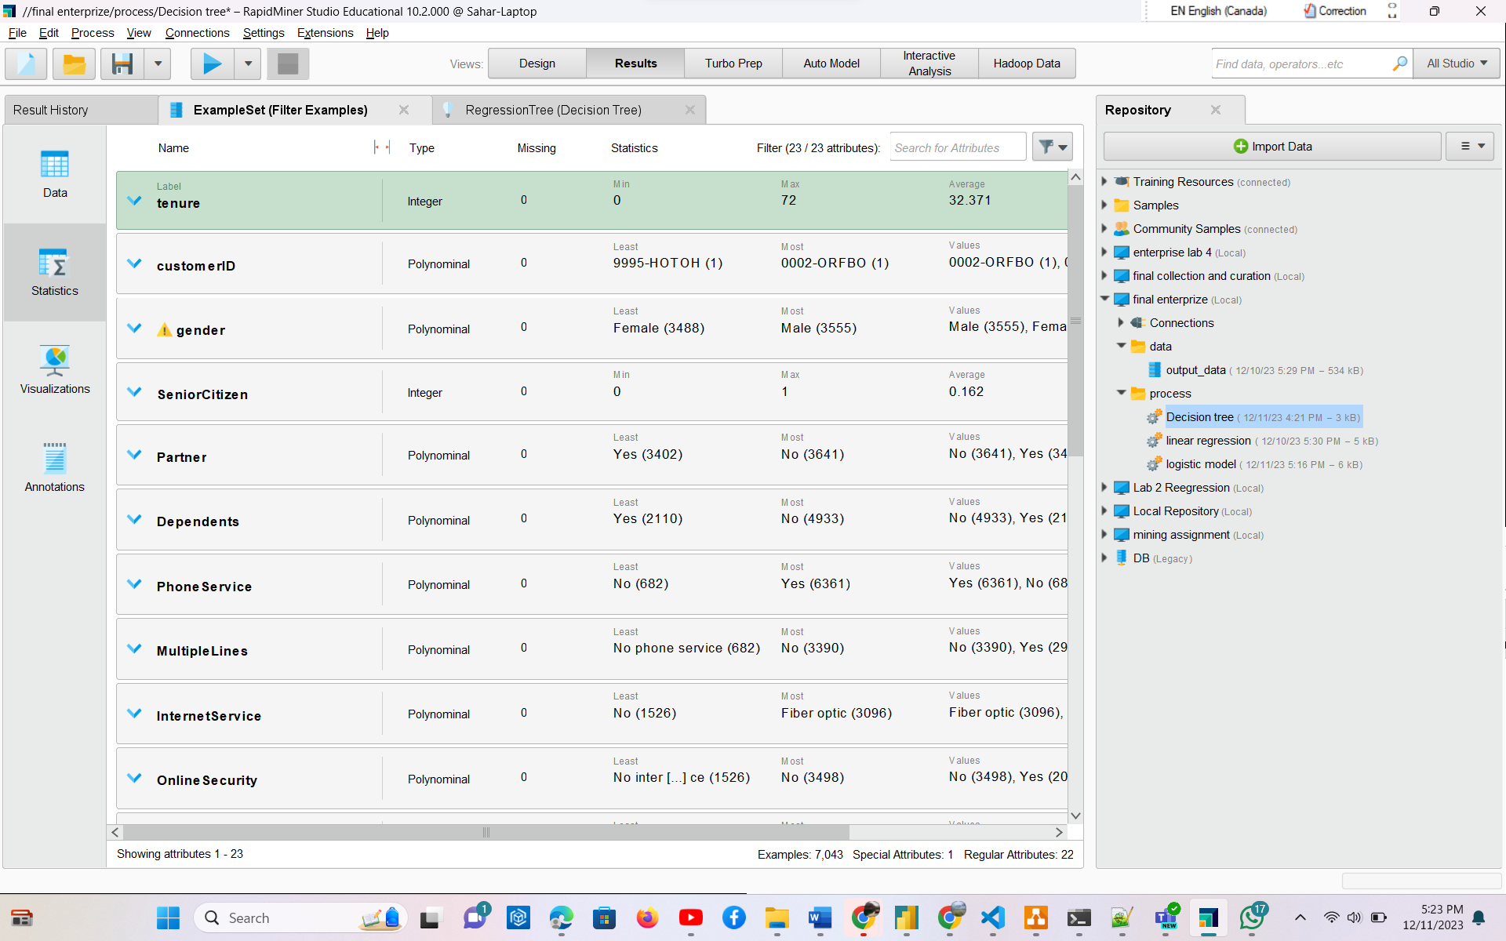

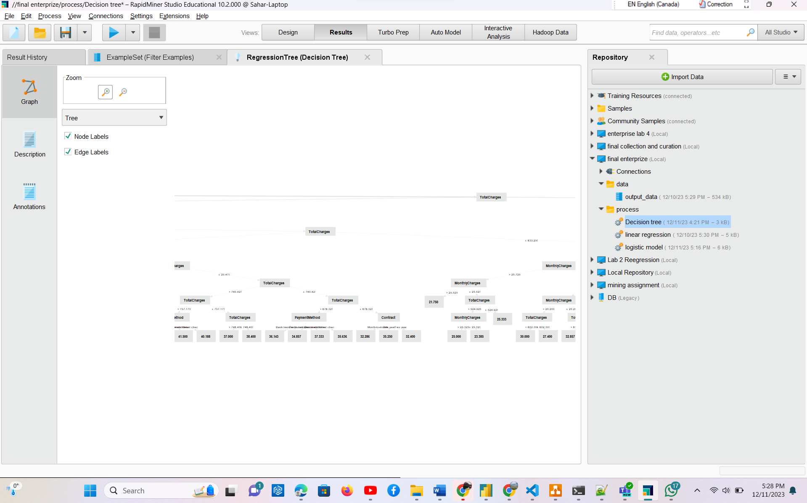

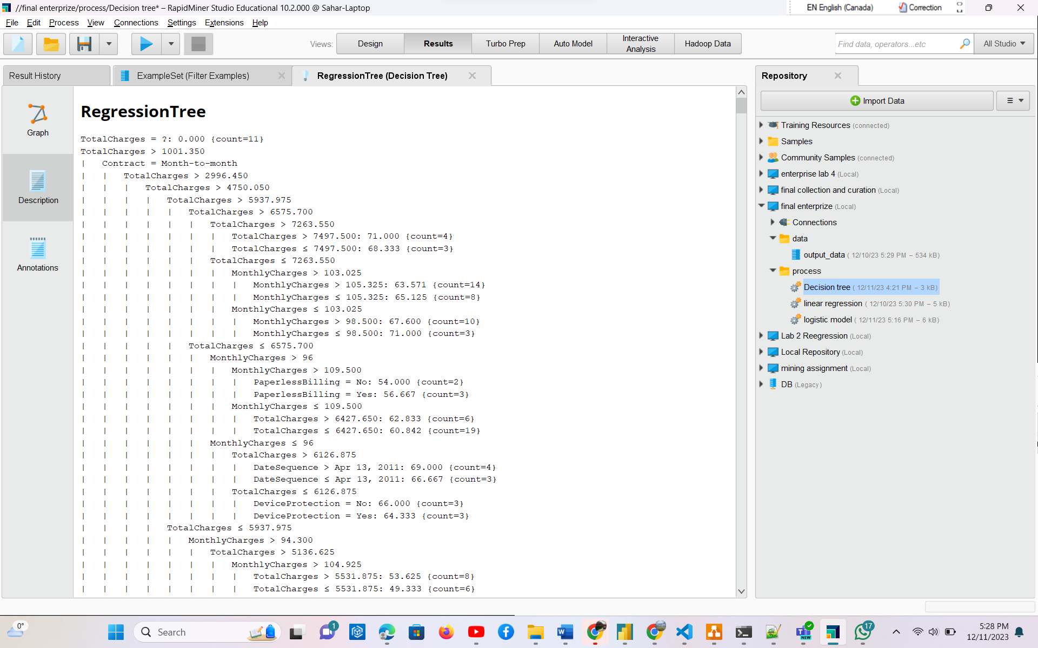

**Auto modeling**

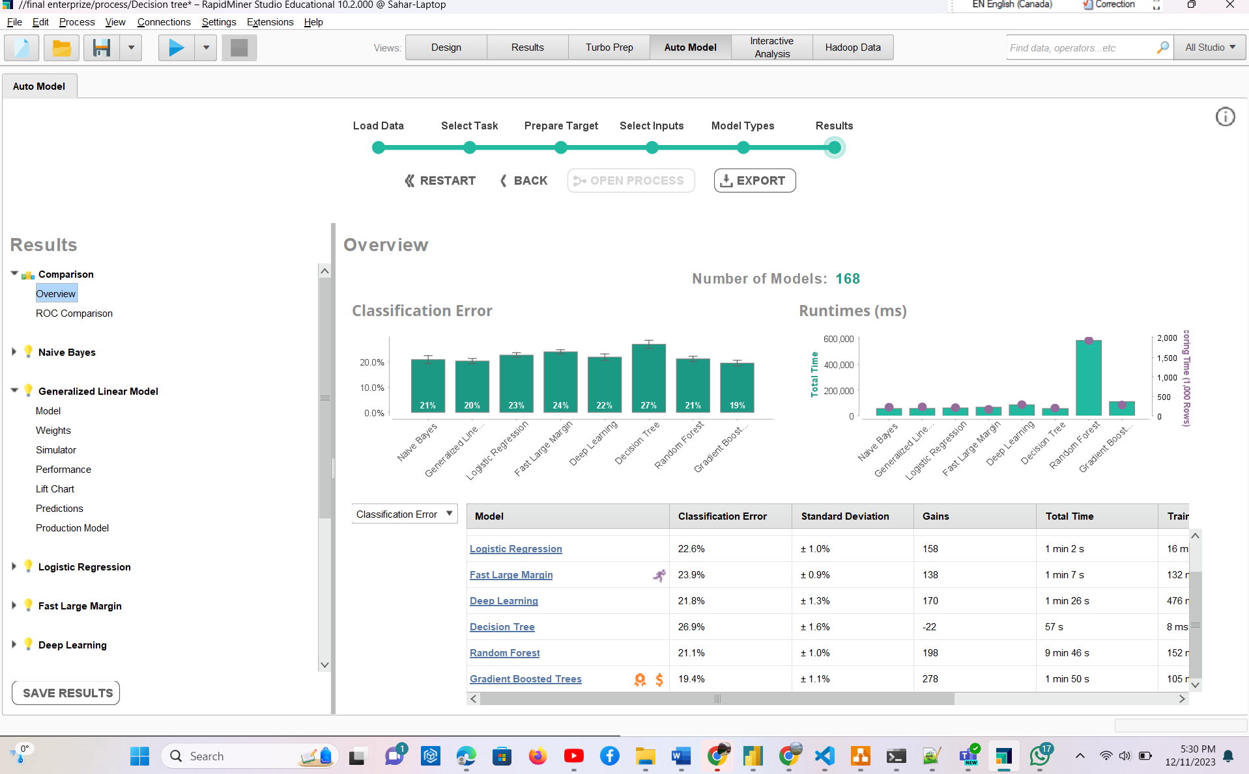

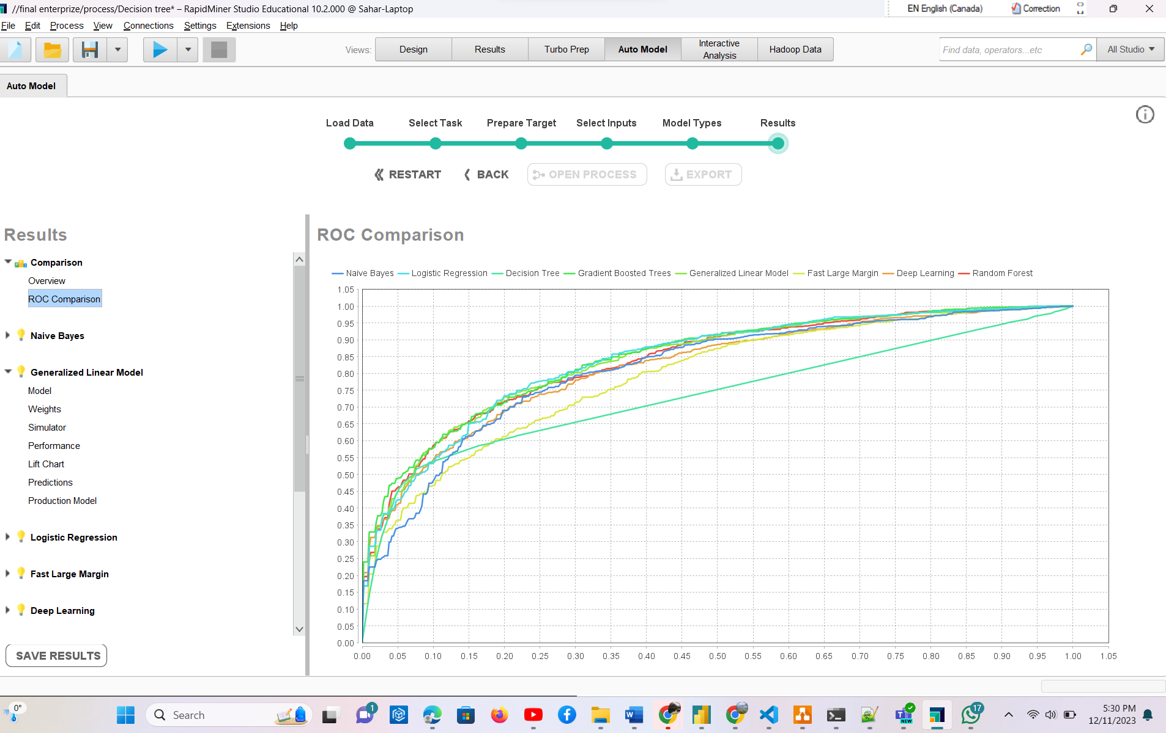

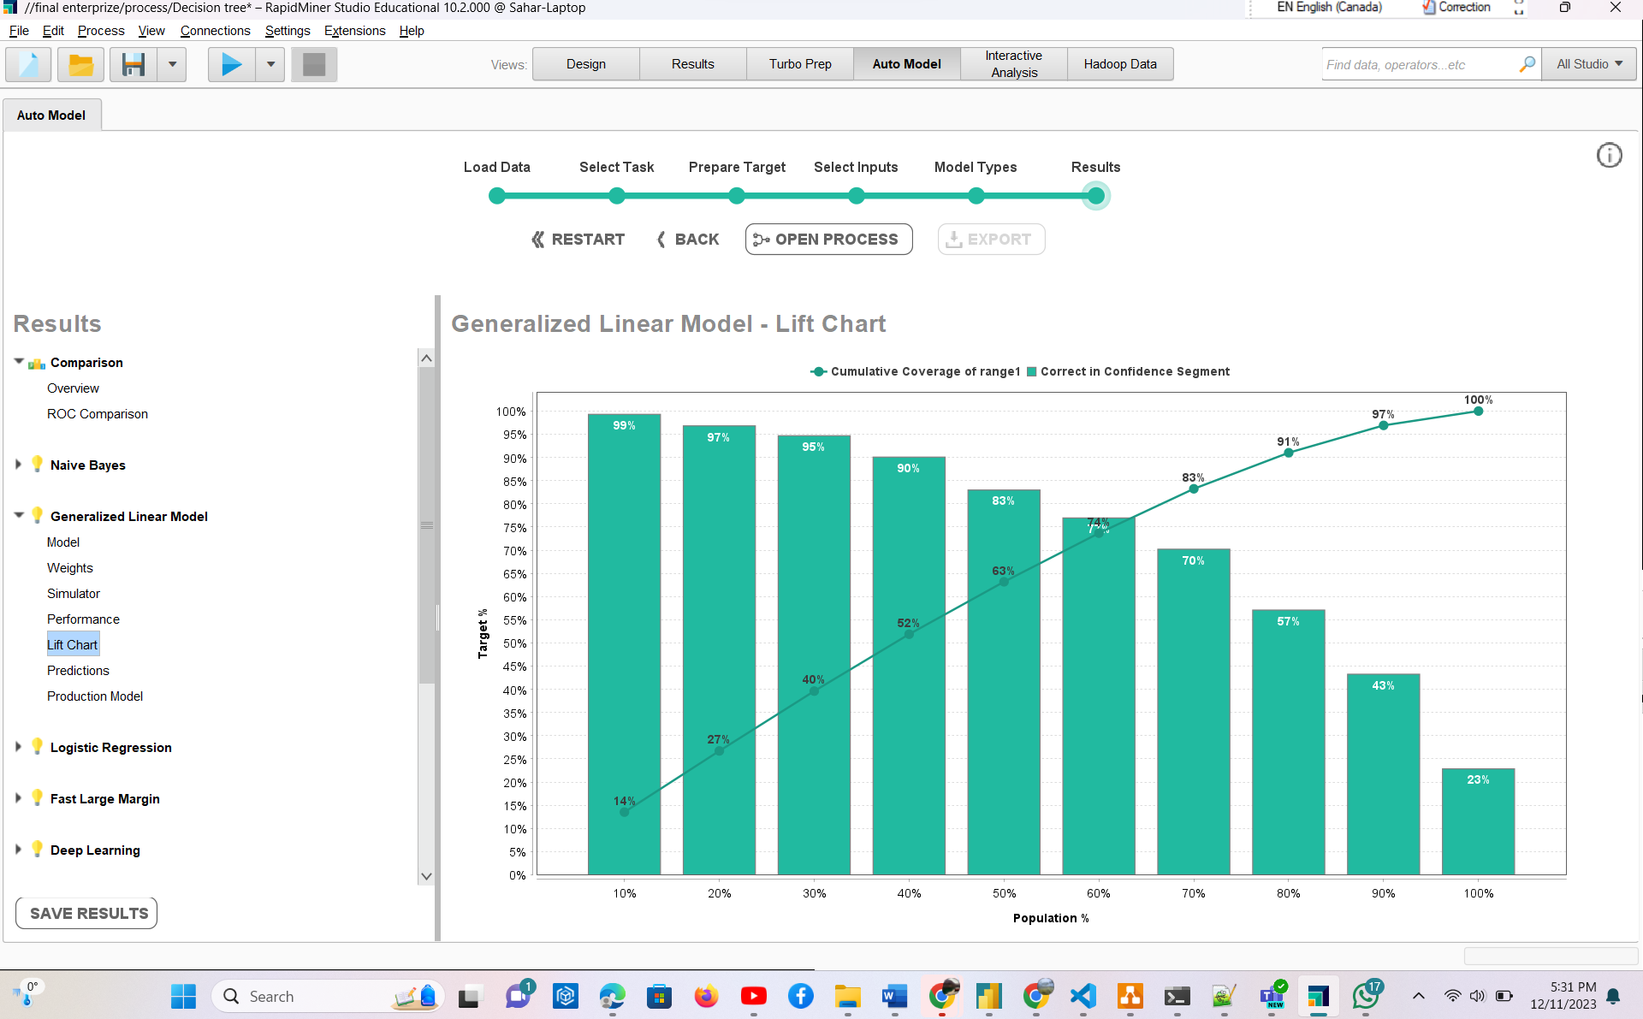

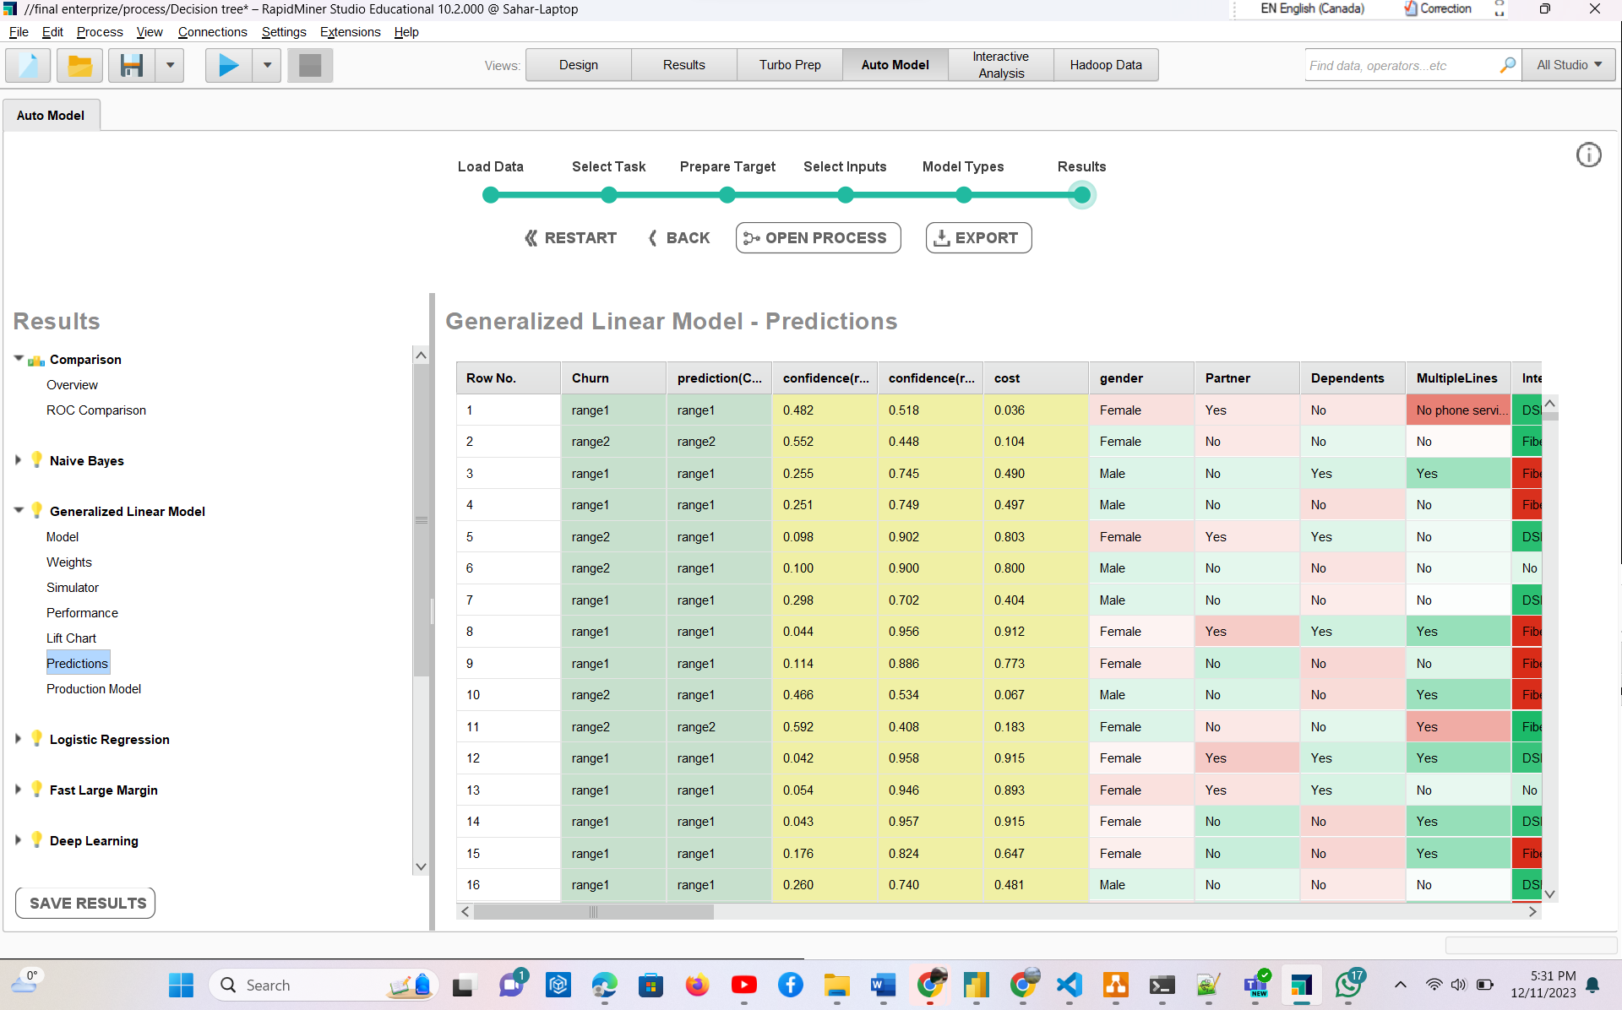

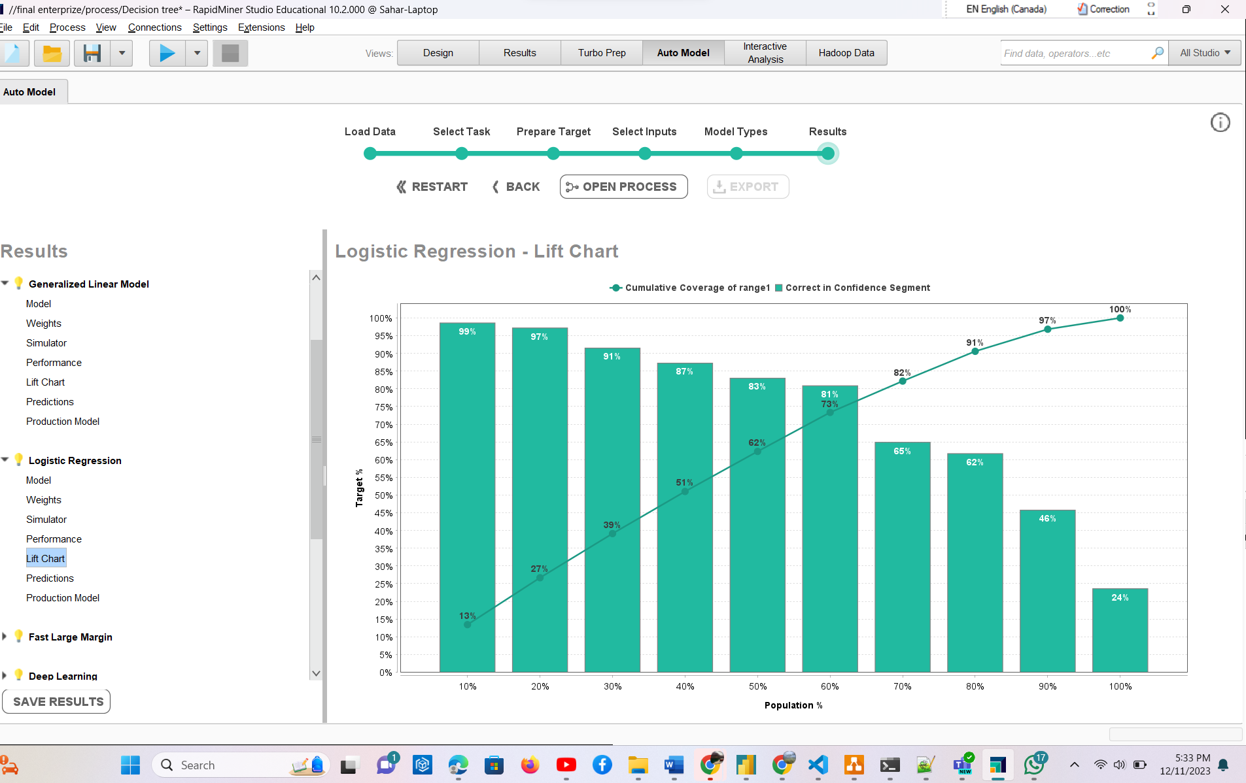

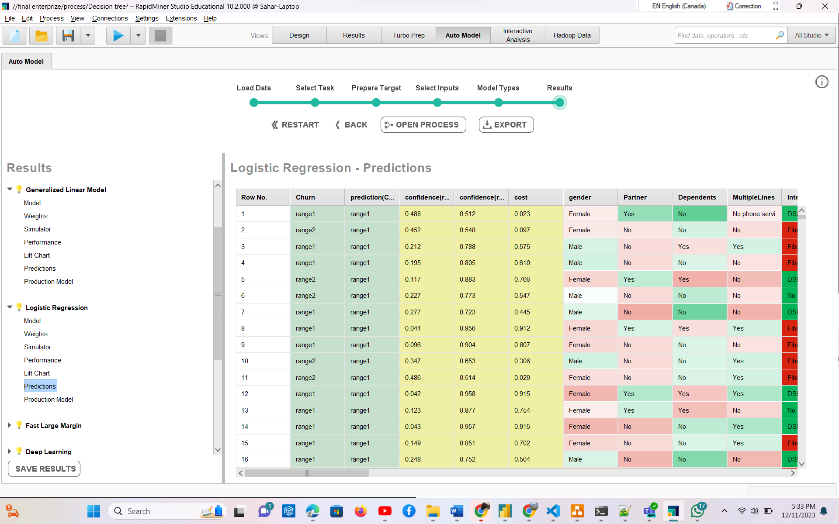

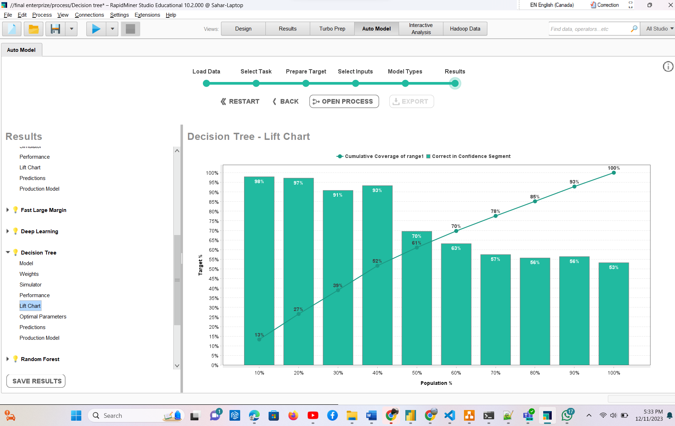

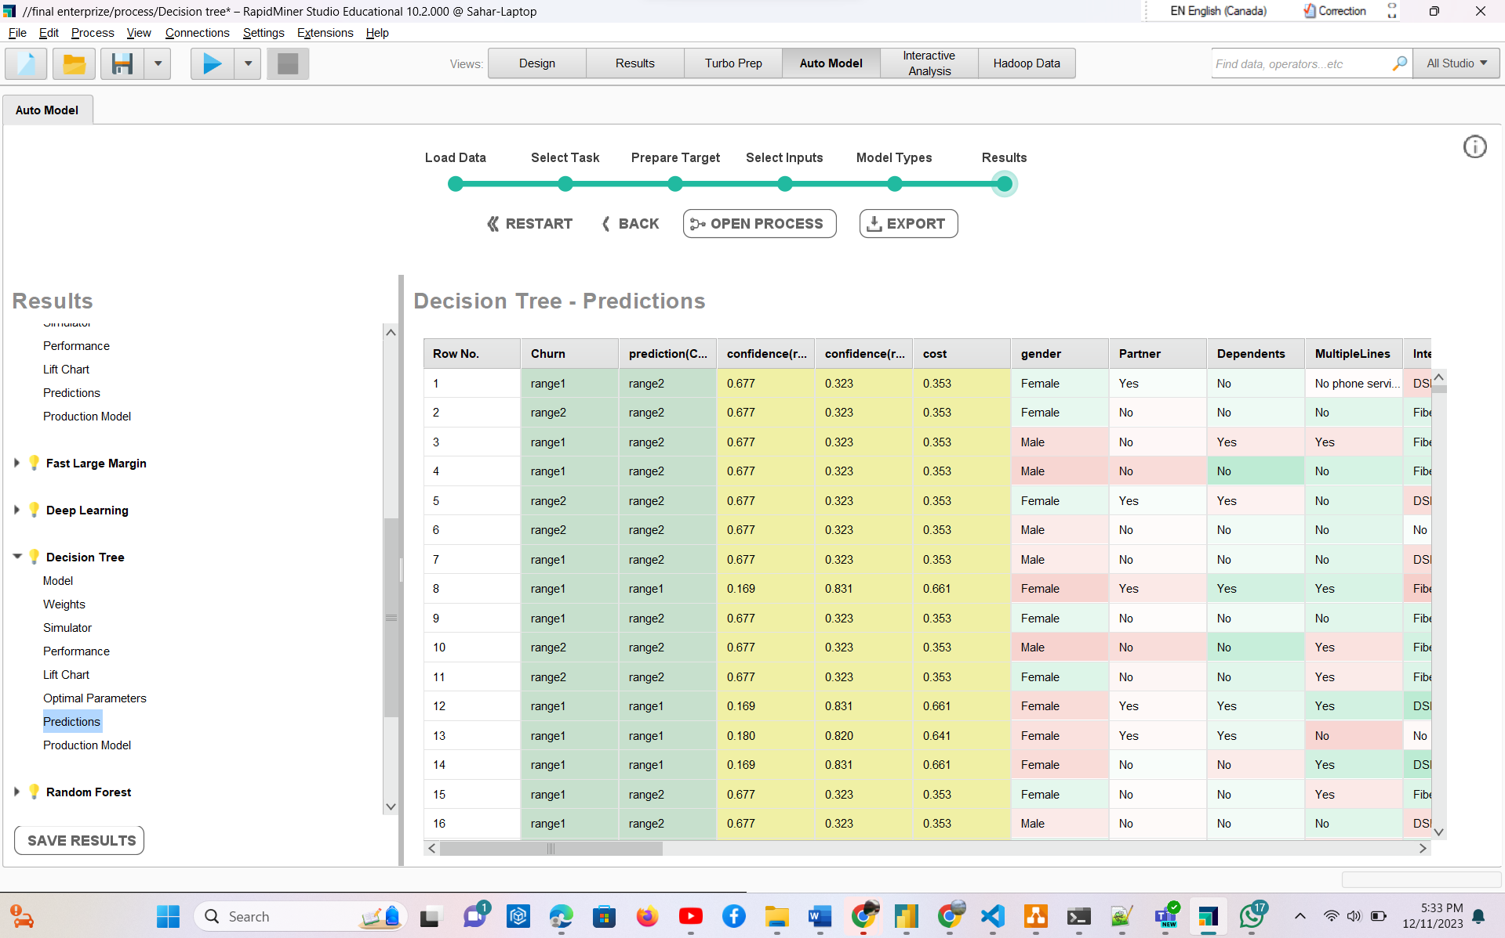

Provie a summary report **(2 Marks)** –

1) Observation of the data and attributes (E.g. You chose to ignore a column/attribute due to missing values).

2) How you prep the data and import in your choice of prediction tool.

**4) Association Mining (4%)**

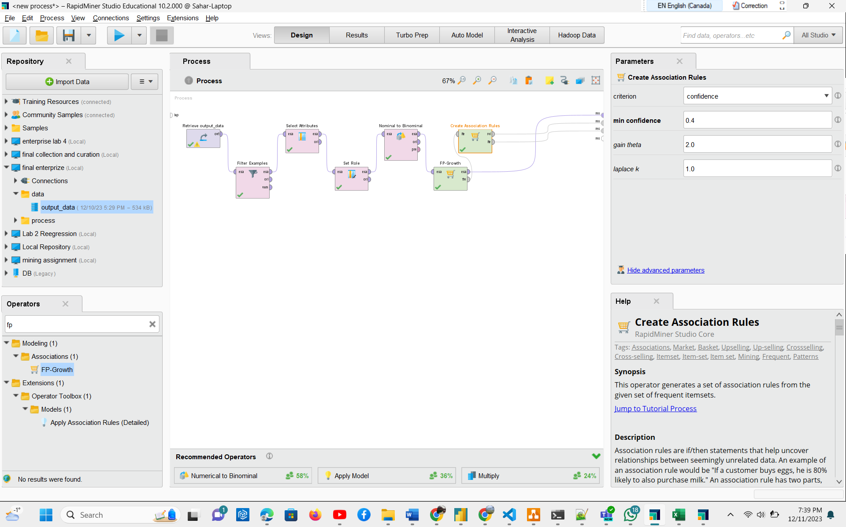

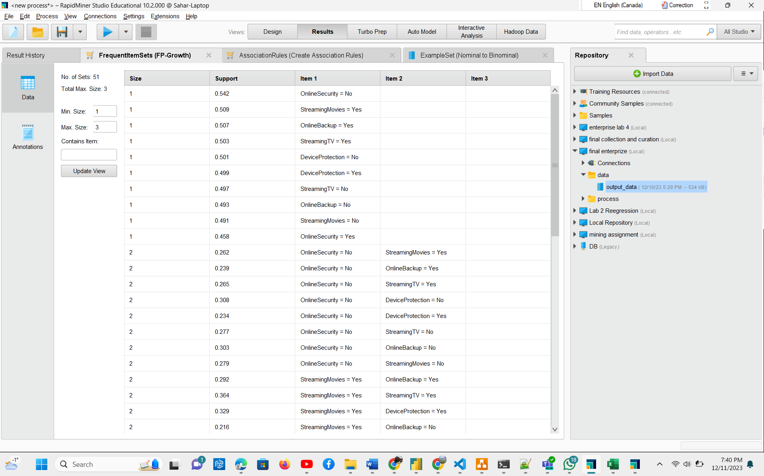

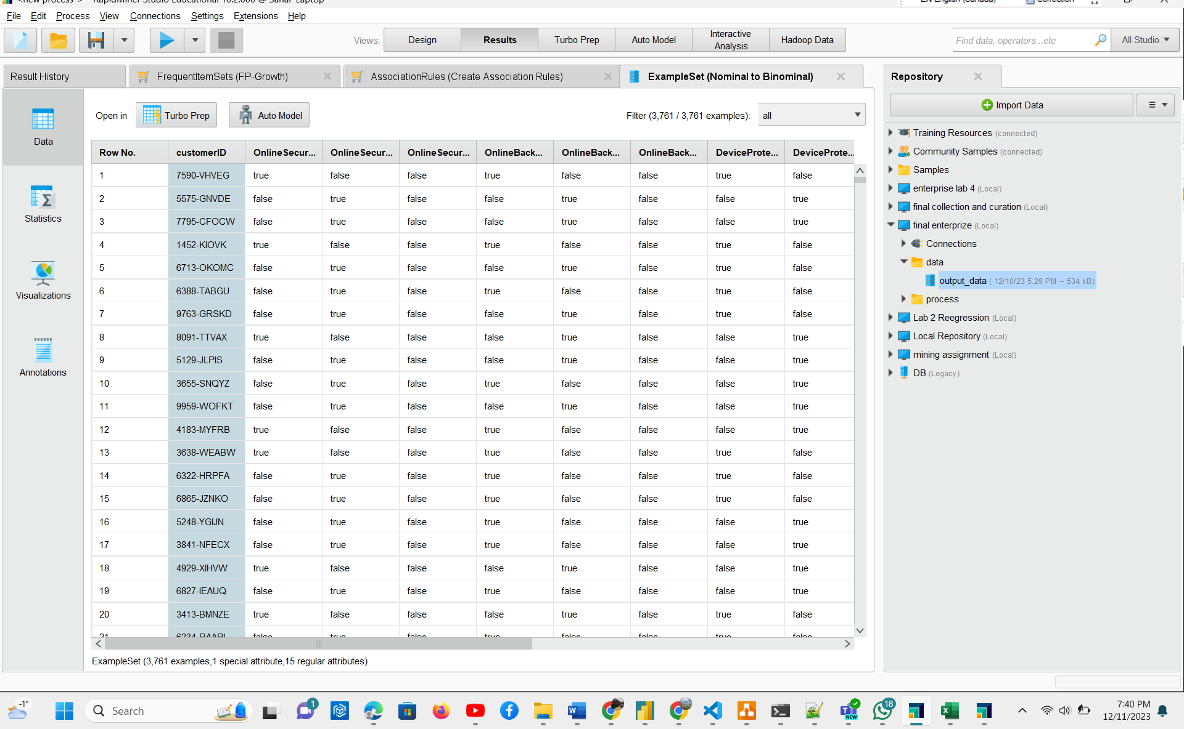

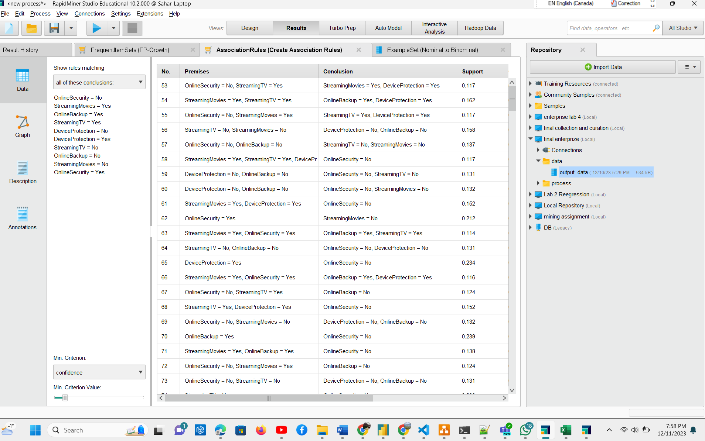

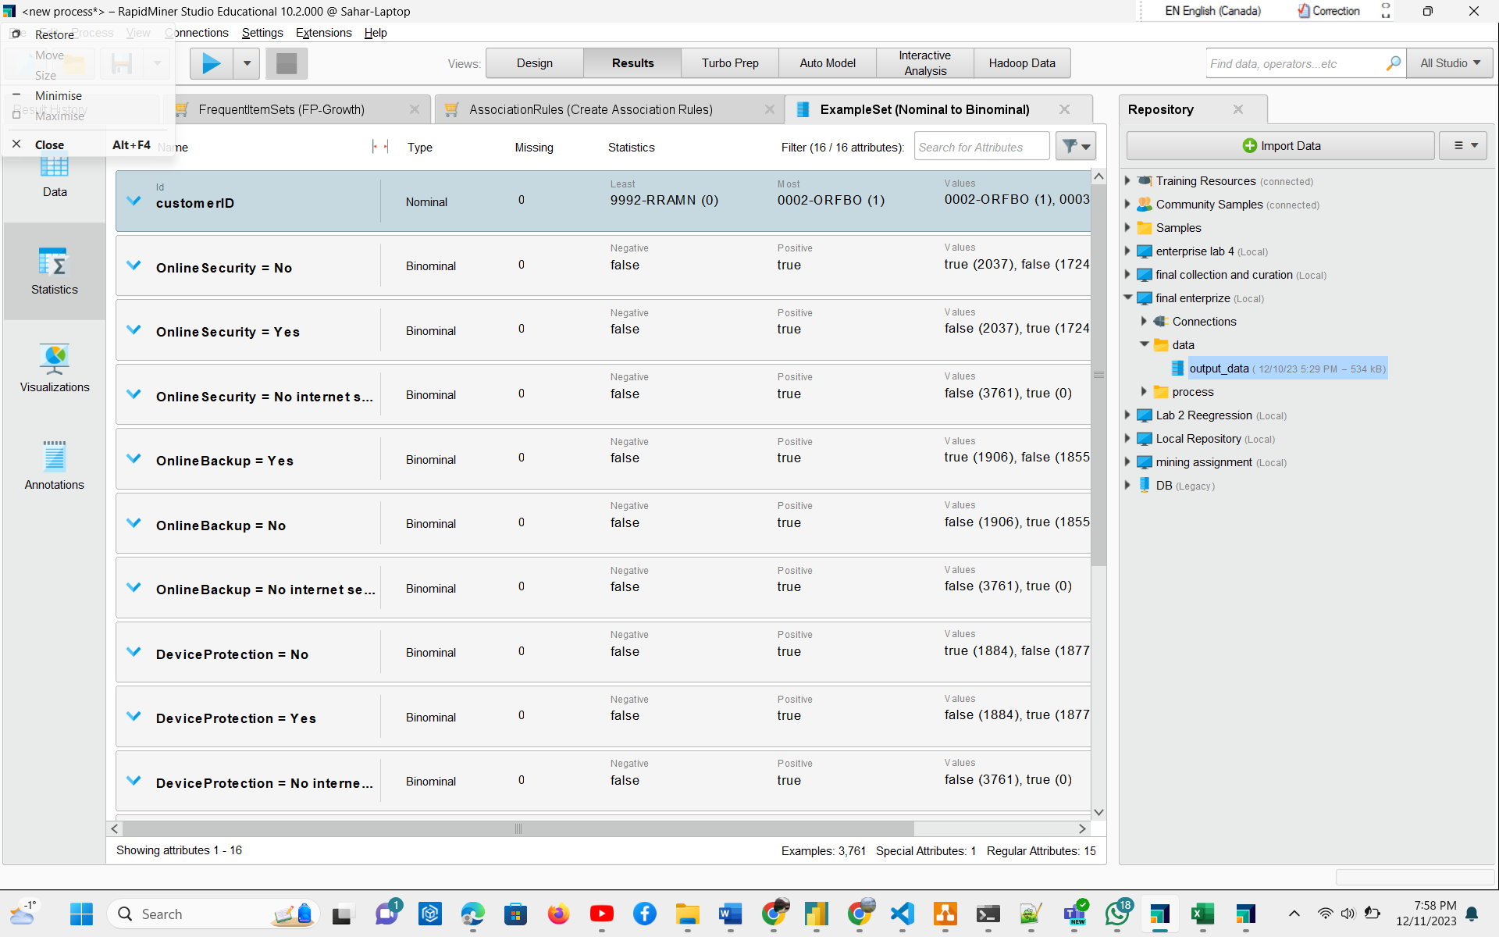

***After changing support and confidence***

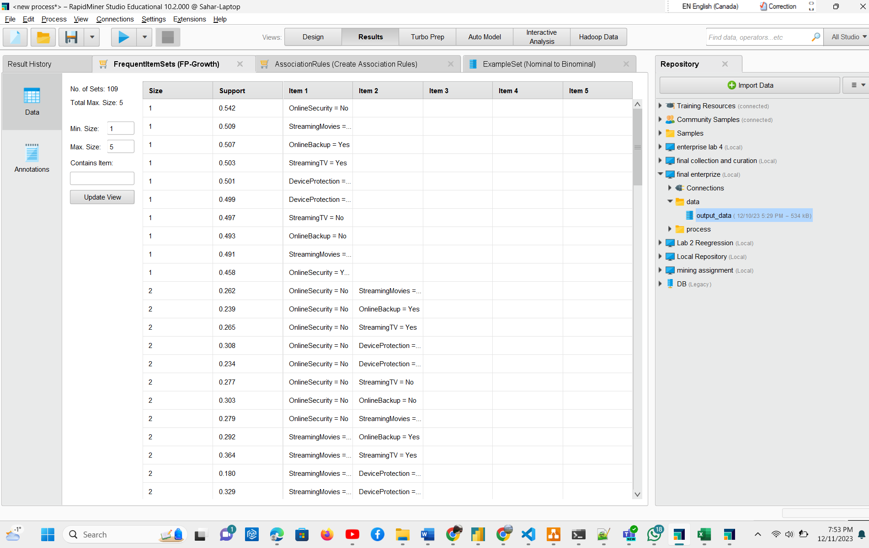

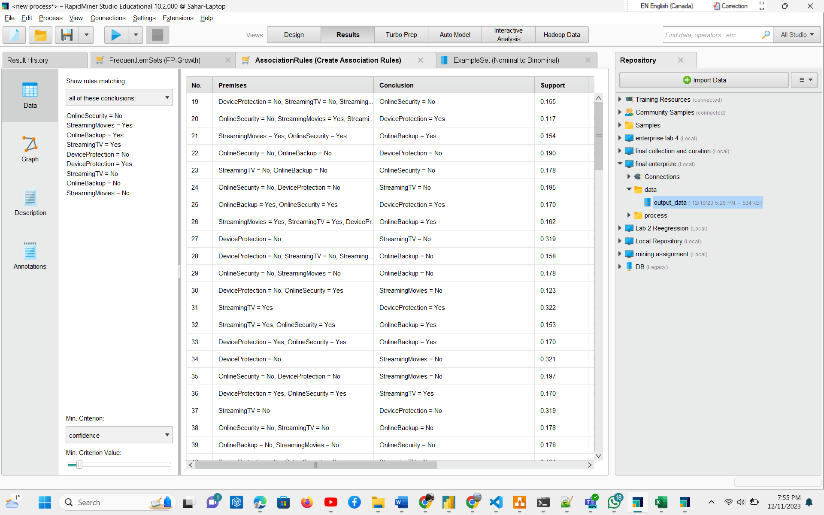

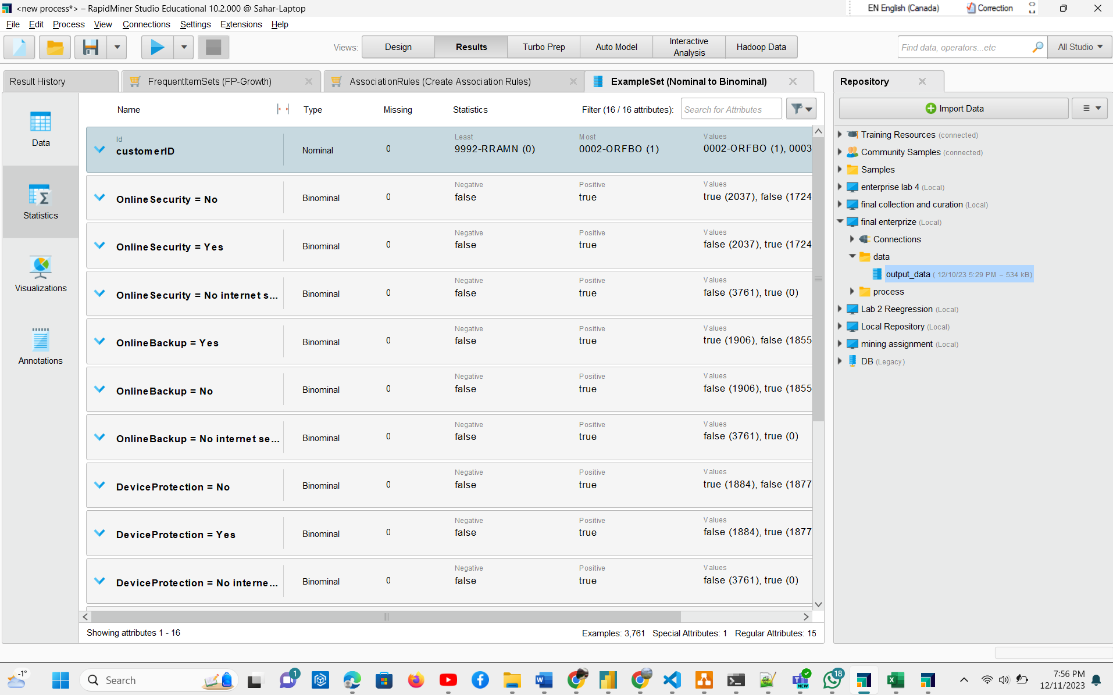

***Top combinations are***

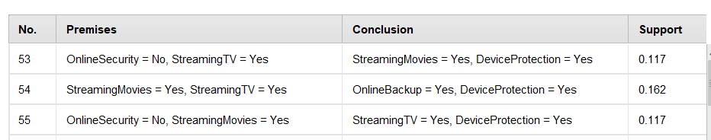 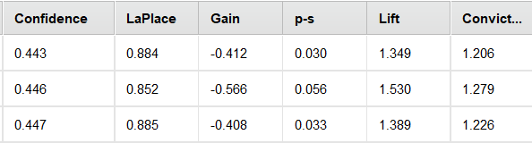

**Submit -**

1) Final Report in Word or PPT or PDF - Ensure all screen shots are provided. Max 10 Slides/Pages. (Please make it simple to read for business users).

2) Charts For part 1 & 2 in Python, Excel or PBI File.

3) For Part 3 – RapidMiner Screenshots.